**AGRO BACKING**

**A PROJECT REPORT**

***Submitted to***

**JAWAHARLAL NEHRU TECHNOLOGICAL UNIVERSITY KAKINADA**

*in partial fulfilment for the award of the degree of*

**BACHELOR OF TECHNOLOGY**

By

**G. YESU BABU (16HP1A05B9)**

**G. KUMAR TATA ARJUN RAJ (16HP1A05A3)**

**Y. SAI TEJA (16HP1A05B1)**

*Under the Esteemed Guidance of*

**Dr. Ch. Rajendra Babu, HOD**



**DEPARTMENT OF COMPUTER SCIENCE AND ENGINEERING**

**ANDHRA LOYOLA INSTITUTE OF ENGINEERING AND TECHNOLOGY**

*(Approved by A.I.C.T.E, New Delhi & Affiliated to JNTU Kakinada)*

VIJAYAWADA

i

**CERTIFICATE**

ANDHRA LOYOLA INSTITUTE OF ENGINEERING AND TECHNOLOGY

DEPARTMENT OF COMPUTER SCIENCE AND ENGINEERING

*(Approved by A.I.C.T.E., New Delhi & Affiliated to JNTU Kakinada)*



*This is to certify that this project entitled “***AGRO BACKING***” is the Bonafede work of*  **G. YESU BABU(16HP1A05B9), G. KUMAR TATA ARJUN RAJ (16HP1A05A3**), **Y. SAI TEJA(16HP1A05B1**) *who carried out the work under our supervision, and submitted in partial fulfilment of the* *requirements for the award of the degree,* BACHELOR OF TECHNOLOGY *in* COMPUTER SCIENCE AND ENGINEERING, *during the academic year* 2019-2020.

**Guide Head of the Department**

**DR. Ch. Rajendra Babu, HOD DR. CHRAJENDRA BABU**

PROFESSORPROFESSOR

External Examiner

ii

**ACKNOWLEDGEMENT**

The successful completion of any task would be incomplete without greeting those who made it possible and whose guidance and encouragement made the effort taken a success.

I extend my heartfelt gratitude to the almighty for giving me strength in proceeding with this project titled **“AGRO BACKING”.**

We here by express our gratitude to the Director **Rev. Fr. Dr. A. Francis Xavier S.J** who has been a constant encouragement for us during the period of project.

We would like to express our thanks to the principal, **Dr. O. Mahesh**, for his inspiration, intensive help and valuable support in every support in every step of our project.

We articulate our gratitude from the depths of our heart to **Dr. Ch. Rajendra Babu, HOD,** **Department of Computer Science and Engineering**, who is a source of simulation and continuous encouragement. We are, indeed, ever indebted to him for his supervision and indispensable help.

We would like to express our thanks to the Coordinator, **Mrs. Razeena Begum**, for her inspiration, intensive help and Valuable support in every step of our project.

We have immense pleasure in expressing our thanks and deep gratitude to our guide

**Dr. Ch. Rajendra Babu Professor of Computer Science and Engineering** for his guidance and encouragement.

We also express our heartfelt gratitude to all members of faculty and non-teaching staff who have definitely contributed their might in the successful completion of project.

We owe deep respect of gratitude to our family members and friends for their loving encouragement, timely suggestions and constant support in finishing this project within the stipulated time.

**G. YESU BABU (16HP1A05B9)**

**G. KUMAR TATA ARJUN RAJ (16HP1A05A3)**

**Y. SAI TEJA (16HP1A05B1)**

iii

**DECLARATION**

We hereby declare that the discussion entitled “**AGRO BACKING”**, submitted for the B. Tech Degree is our original work and dissertation has not formed the basis for the award of any degree, associate ship, fellowship or any other similar titles.

Place: Vijayawada

Date:

**G. YESU BABU (16HP1A05B9)**

**G. KUMAR TATA ARJUN RAJ (16HP1A05A3)**

**Y. SAI TEJA (16HP1A05B1)**

**iv**

**ABSTRACT**

**AGRO BACKING** is a web application which mainly concentrates on creating a platform for

farmers who are not able to find proper investment for their crops. We see many of the

farmers committing suicides due to lack of investment for their cultivation and being cheated

by many of the money lenders in the name of interests, this web app enables them to find

investors. It will be used to gather information regarding various crops and their outcomes in

different regions of the state and the farmers can approach the investors for help using this

web app. Farmers can register in this web app and enrol their personal details and data

regarding the crops they have cultivated in the past. Once they get registered in this web app,

they will be getting notifications regarding the investors who are willing to invest in their

cultivation out of their interest.

**v**

**CONTENTS**

**1. ABSTRACT** v

**2. LIST OF FIGURES** ix

**3. LIST OF TABLES** ix

**Title Page no**

1. **INTRODUCTION 1-2**

**1.1** About the project

**1.2** Purpose

**1.3** Motivation

**1.4** Scope

**2. LITERATURE SURVEY**

**3. SYSTEM STUDY AND ANALYSIS**

3.1 Feasibility Study

3.2 Existing System and Disadvantages

3.3 Proposed System and Advantages

**4. SYSTEM REQUIREMENTS**

4.1 Software Requirements

4.2 Hardware Requirements

**5. SYSTEM DESIGN**

**vi**

5.1 System Architecture

5.2 UML Diagrams

5.2.1 Class Diagram

5.2.2 Use case Diagram

5.2.3 Sequence Diagram

5.2.4 Activity Diagram

5.2.5 State Chart Diagram

5.2.6 Collaboration Diagram

5.2.7 Component Diagram

5.2.8 Deployment Diagram

**6. SOFTWARE ENVIRONMENT**

6.1 Python

6.2 Features of Python

6.3 Installation of Python

6.4 Installation of Python Modules using PIP

**7. DATABASE**

7.1 About database

7.2 Advantages of database

**8. SYSTEM IMPLEMENTATION**

8.1 Module and its Description

8.2 Sample code

**9. TESTING**

9.1 Types of tests

**vii**

9.1.1 Unit Testing

9.1.2 Integration Testing

9.1.3 Functional Testing

9.1.4 System Testing

9.2 Testing Methodologies

9.3 Testing Strategy

9.4 Test cases

**10. EXPERIMENTAL RESULTS**

**11.** **CONCLUSION**

**12. FUTURE WORK**

**13. REFERENCES**

**vii**

**LIST OF FIGURES**

|  |  |  |
| --- | --- | --- |
| **Figure no** | **Name** | **Page No** |
| 5.2.1 | Class Diagram |  |
| 5.2.2 | Use case Diagram |  |
| 5.2.3 | Sequence Diagram |  |
| 5.2.4 | Activity Diagram |  |
| 5.2.5 | State Chart Diagram |  |
| 5.2.6 | Collaboration Diagram |  |
| 5.2.7 | Component Diagram |  |
| 5.2.8 | Deployment Diagram |  |

**LIST OF TABLES**

|  |  |  |
| --- | --- | --- |
| **Table no** | **Name** | **Page No** |
| 9.4 | Test cases |  |

**viii**

**CHAPTER-1**

**INTRODUCTION**

**1.1 ABOUT PROJECT:**

We see many farmers who have their own land and know very well about

farming commit suicides due to lack of investment for their crops. It is the penniless

situation which led them to take such a decision and leave their families destitute. Our

web app is designed to help all those farmers who were not able to get any resource

for their farming. We are creating a platform where farmers can get investors for their

farming.

we would like to depict the situation where in many of the farmers are committing suicides due to lack of money to invest and unlawful debts. We strive to eradicate this situation and help them in one way or the other by exposing them and their crop to someone who is really willing to invest for their crops.

.

* 1. **PURPOSE OF THE PROJECT**

The main aim of this project is to provide a supporting back-bone for all those farmers who know well and good about farming but don't have enough money to invest for their own land. Hence, we bring them and backers(investors) on to a single platform so that they can further in farming and helps them to grow more crops out of their situation.

**1.3 MOTIVATION**

* To effectively provide appropriate agricultural information in order to increase awareness.
* To promote and strengthen efficient and effective management of agricultural production and productivity in order to ensure sustainable household and national food and nutrition security, and increased incomes.
* To eradicate the situations where farmers are struggling to get investment for their farming.
* Agriculture has the contribution of 16% in the gross domestic product (GDP) of the country.
* The agricultural sector also provides livelihood to two-thirds of the population.

**Scope:**

Agriculture is a production plant where the free gifts of nature such as land, water, air, soil energy, etc. are used as inputs and then converted into a single primary unit that is crop plants and their yield which are indispensable for human beings. Those primary units are consumed by animals and are converted into secondary units like milk, meat, eggs, wool, honey, silk, etc. Over 58% of the rural households depend on agriculture as their principal means of livelihood. India is one of the largest exporters of agricultural commodities such as spices, flowers, mushrooms, oilseeds, milk, rice, food grains and other vegetables. We believe that if the agricultural sector of a country is strong, it acts as-as a wall in maintaining food security and in the process, national security as well. So, we tried to develop a platform where farmers receive help and this process continues.

**CHAPTER-2**

**LITERATURE SURVEY**

**2.1 LITERATURE SURVEY**

Literature survey in the project report represents the ground study you have done for the completion of your project. It can include

1. A book: act as a reference for the concepts you used in your project.

2. Research papers: It can also act as a reference for the theories. However, most of the cases you critically compare them and establish your purpose for the project and improvement.

**Evolution of Agriculture**

Man in his primeval stage was a hunter and gatherer and during the Neolithic period he learned the art of cultivation of crops. Thus, agri­culture had been the dominant economic activity in the past and it is still the mainstay of over two-third of the world population. Humans invented agriculture during the Neolithic era, or the New Stone Age, which occurred between 7,000 and 10,000 years ago. There were eight Neolithic crops: emmer wheat, einkorn wheat, peas, lentils, bitter vetch, hulled barley, chick peas, and flax. The Neolithic era ended with the development of metal tools.

Evidence suggests that irrigation first appeared in Egypt and Mesopotamia in the sixth millennium B.C. Various people groups began digging and repairing canal networks, which helped to regulate the flow of rivers, such as the Nile River in Egypt. Floods caused by the yearly inundation of the Nile would have had disastrous effects for ancient farmers, washing away dikes and swamping fields. Conversely, when the waters were low the land dried up, killing crops. The canal networks eventually developed into sophisticated irrigation systems. The oldest method of irrigation, which made use of man-made underground streams called qanats, is still being used in parts of the Middle East.

Between the 17th century and the 19th century Britain experienced a dramatic increase in agricultural productivity known as the British Agricultural Revolution. This "revolution" consisted of a variety of improvements to agricultural methods, which took place more or less simultaneously. Farmers developed new methods of crop rotation, began cultivating land that had been marshy or forested, and planted new crops such as the turnip.

During the past 10 years, a huge controversy has raged over the use of chemical pesticides and fertilizers on farms. Growing awareness of how chemicals impact human health and the environment has led to calls for increased government regulation of the agricultural industry. As the pesticides result in increase of outcome all the farmers started using them and tend to buy them even it is highly difficult to buy, which results in severe debts. As the days pass by it became mandatory for farmers to use pesticides to protect crop from different types of insects in their crops and tend to lend money from lenders for high interest rates. This led them to situations where they cannot repay their debts if they failed to get expected outcome.

**CHAPTER-3**

**SYSTEM STUDY AND ANALYSIS**

**3.1 FEASIBILITY STUDY**

An analysis of the ability to complete a project successfully, taking into account legal, economic, technological, scheduling. Rather than just diving into a project and hoping for the best, a feasibility study allows project managers to investigate the possible negative and positive outcomes of a project. Many Feasibility studies are disillusioning for both users and analysts. First, the study often presupposes that when feasibility document is being prepared, the analyst is in a position to evaluate solutions. Second, most studies tend to overlook the confusion inherent in the system development constraints and the assume attitudes. The feasibility study is to serve as a decision document for a project. Three key considerations involved in the feasibility analysis:

* Economic Feasibility
* Technical Feasibility
* Social Feasibility

**ECONOMIC FEASIBILITY**

The purpose of economic feasibility study is to demonstrate the net benefit of a proposed project for accepting or disbursing electronic funds/benefits, taking into consideration the benefits and costs to the agency. The project “AGRO BACKING” is carried out to check the economic impact that the system will have on the organization. The amount of fund that the investor can pour in and development of the system is not limited and it is based on the type of crop they are farming. The expenditures must be justified. Thus, the developed system as well within the budget and this was achieved because most of the technologies used are freely available.

**TECHNICAL FEASIBILITY**

Technical feasibility is concerned with specifying equipment and software that will successfully satisfy the user requirements. The technical needs of the system may vary considerably, but might include the facility to produce outputs in a given time, response time under certain conditions. The project “AGRO BACKING” is technically feasible as the system developed will be highly available with technical resources. The developed webpage must have a modest requirement, as only minimal or null changes are required for implementing this webpage.

**SOCIAL FEASIBILITY**

The effect that a proposed project may have on the social system in the project environment is addressed in the social feasibility. It may happen that a particular category of entities may be short or not available as a result of ambient social structure. The influence on the social status of the participants by the project should be evaluated in order to guarantee compatibility must be identified that users in the particular area may have specific status symbols with in the region. The aspect of study is to check the level of acceptance of the system by the user. The project “Agro Backing” will become more of social use and help many farmers in around the globe.

**3.2 EXISTING SYSTEM**

Many different systems were in use for farmers regarding the kind of crops they can cultivate and pesticides that can be used to improvise their outcome, but there was no system which helps in providing investment for their crops.

**Disadvantages:**

* No proper estimation of the expenditure for crops being cultivated.
* Systems are not being available for free use and some of them are not even accessible in many of the regions.

**3.3 PROPOSED SYSTEM**

In the proposed system, it mainly concentrates on exposing the farmers, who are struggling to carry forward their farming due to lack of money. Those farmers who are economically weak are not able to do anything despite of their skills and hard work. Farmers are not able to repay their debts and committing suicides, hence with this platform they can raise their voice and urge for help so that there will be no loss of lives and there won't be any heartaches to farmer's families.

By using this system farmers can estimate the expenditure beforehand and make proper planning as per the requirements. Farmers will not depend on money lenders anymore and they can bring out their problems through this system which will have some good number of high professionals in the society as investors. Agricultural farmers will be exposed to outside world and they invite investments from many people.

* User friendly
* Easy to access
* Helps outing in gathering investments for cultivation.
* Decrease suicides being committed by farmers due to lack of money.
* Increases the national income

**CHAPTER-4**

**SYSTEM REQUIREMENTS**

**4.1 Requirement specification**

Software Requirements Specification forms the basis of an organization's entire project. It sets out the framework that all the development teams will follow. It provides critical information to all the teams, including development, operations, quality assurance (QA) and maintenance, ensuring the teams are in agreement.

**4.1.1 Functional Requirements:**

In software engineering, a functional requirement defines a function of a software system or its component. A function is described as a set of inputs, the behaviour, and outputs (see also software). Functional requirements may be calculations, technical details, data manipulation and processing and other specific functionality that define what a system is supposed to accomplish. Behavioural requirements describing all the cases where the system uses the functional requirements are captured in use cases. Generally, functional requirements are expressed in the form “system shall do”. The plan for implementing functional requirements is detailed in the system design. In requirements engineering, functional requirements specify particular results of a system. Functional requirements drive the application architecture of a system. A requirements analyst generates use cases after gathering and validating a set of functional requirements. The hierarchy of functional requirements is: user/stakeholder request -> feature - > use case -> business rule. Functional requirements drive the application architecture of a system. A requirements analyst generates use cases after gathering and validating a set of functional requirements. Functional requirements may be technical details, data manipulation and other specific functionality of the project is to provide the information to the user.

**The following are the Functional requirements of our system:**

1. Acquiring data sets related to all kinds of crops from resources.
2. Data pre-processing and dividing the data based on various factors.
3. A frame work to analyse the data being shared by the farmer.

**4.1.2 Non-Functional Requirements:**

In systems engineering and requirements engineering, a non-functional requirement is a requirement that specifies criteria that can be used to judge the operation of a system, rather than specific behaviours The project non-functional requirements include the following.

1. Updating the data related to crops.
2. Problem resolution and error occurrence in the system

**Availability:** A system’s “availability” or “uptime” is the amount of time that is operational and available for use. It’s related to is the server providing the service to the users in displaying images. As our system will be used by thousands of users at any time our system must be available always. If there are any cases of updations they must be performed in a short interval of time without interrupting the normal services made available to the users.

**Efficiency**: Specifies how well the software utilizes scarce resources: CPU cycles, disk space, memory, bandwidth etc. All of the above-mentioned resources can be effectively used by performing most of the validations at client side and reducing the workload on server by using JSP instead of CGI which is being implemented now.

**Flexibility**: If the organization intends to increase or extend the functionality of the software after it is deployed, that should be planned from the beginning; it influences choices made during the design, development, testing and deployment of the system. New modules can be easily integrated to our system without disturbing the existing modules or modifying the logical database schema of the existing applications.

**Portability:** Portability specifies the ease with which the software can be installed on all necessary platforms, and the platforms on which it is expected to run. By using appropriate server versions released for different platforms our project can be easily operated on any operating system, hence can be said highly portable.

**Scalability:** Software that is scalable has the ability to handle a wide variety of system configuration sizes. The non-functional requirements should specify the ways in which the system may be expected to scale up. Any additional requirements such as hardware or software which increase the performance of the system can be easily added. An additional server would be useful to speed up the application.

**Integrity**: Integrity requirements define the security attributes of the system, restricting access to features or data to certain users and protecting the privacy of data entered into the software. Certain features access must be disabled to normal users such as adding data, searching which is the sole responsibility of the server. Access can be disabled by providing appropriate logins to the users for only access.

**Usability:** Ease-of-use requirements address the factors that constitute the capacity of the software to be understood, learned, and used by its intended users. Hyperlinks will be provided for each and every service the system provides through which navigation will be easier. A system that has high usability coefficient makes the work of the user easier.

**Performance:** The performance constraints specify the timing characteristics of the software.

**4.2 Software Requirements:**

* Operating System - Windows
* Coding language - Python
* IDLE - Microsoft Visual Code
* Technology - HTML, CSS, Ajax, JavaScript
* Framework - Flask
* Data base - PostgreSQL

**4.3 Hardware Requirements:**

* Hardware - Pentium IV
* Processor - 2 GHz multicore processor
* RAM - 4GB
* Hard Disk - 20GB (minimum)

**CHAPTER-5**

**SYSTEM DESIGN**

**5.1 SYSTEM ARCHITECTURE**

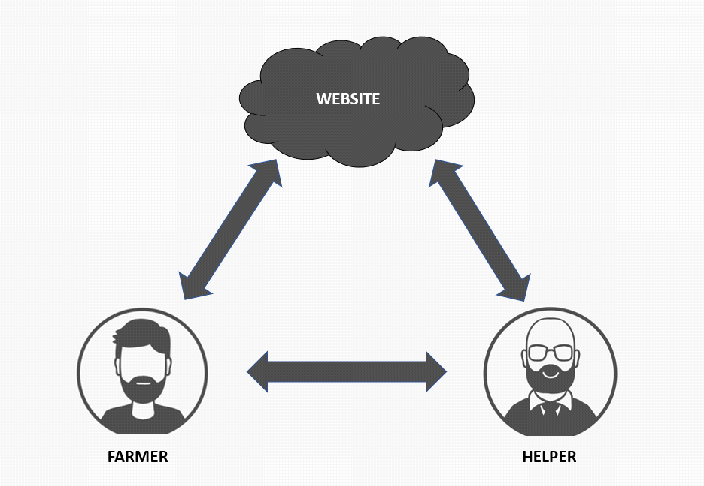

The overall system design consists of following modules:

**Home:**

Just as we open the website, we will be seeing home page from where we can navigate through the website and use all the services.

**Profile:**

Profile button is used to register a new user and if the existing users are about to login they can login using this.

**Register:**

**R**egister module is to enrol a new user to the website and create an account for that user based on the account type they have selected.

**Login:**

**E**xisting users can login into their accounts by selecting login which enables them to go through their profile and for the farmers if they want to update the type of crop and other details they can change after logging into their account.

**Log out:**

**L**og out is used to log out from that particular account whether it is a farmer or an investor.

**Services:**

**S**ervices button will redirect to the services offered by our website which include the data from various districts about various crops and the outcomes in that district. It also provides the way to the investor (like filter) for searching the farmers.

**About us:**

**A**bout us is about our team, who developed this website and how we get this idea to develop a website like this. Our intention and mission. A brief description of the scenarios of farmers struggling, which resulted in this kind of website.

**Contact us:**

**C**ontact uspage gives all the information including mail and contact

numbers of our team so that users can reach out to us at any hour, if they face any

kind of errors in the entire website and in the process of their account creation.

**Request:**

Another module of sending a request message by farmers is also added, where farmers can approach their nearby investors and ask them for investment. In this module one can send request to investor if and only if the investor allows his identity to be public.

**5.2 UML DIAGRAMS**

UML diagrams are the ultimate output of the entire discussion. All the elements, relationships are used to make a complete UML diagram and the diagram represents a system. The visual effect of the UML diagram is the most important part of the entire process. All the other elements are used to make it complete. UML includes the following nine diagrams, the details of which are described in the subsequent chapters

* Class Diagram
* Object Diagram
* Use case Diagram
* Sequence Diagram
* Collaboration Diagram
* Activity Diagram
* State Chart Diagram
* Deployment Diagram
* Component Diagram

There are three important types of UML modelling.

**STRUCTURAL MODELING**

Structural modelling captures the static features of a system. They consist of the following-

* Class diagrams
* Object diagrams
* Deployment diagrams
* Package diagrams
* Composite structure diagram
* Component diagrams

Structural model represents the framework for the system and this framework is the place where all other components exist. Hence, the class diagram, component diagram and deployment diagrams are part of structural modelling. They all represent the elements and the mechanism to assemble them.

The structural model never describes the dynamic behaviour of the system. Class diagram is the most widely used structural diagram.

**BEHAVIORAL MODELING**

Behavioural model describes the interaction in the system. It represents the interaction among the structural diagrams. Behavioural modelling shows the dynamic nature of the system. They consist of the following –

* Activity diagrams
* Interaction diagrams
* Use case diagrams

All the above show the dynamic sequence of flow in a system.

**ARCHITECTURAL MODELING**

Architectural model represents the overall framework of the system. It contains both structural and behavioural elements of the system. Architectural model can be defined as the blueprint of the entire system. Package diagram comes under architectural modelling.

**5.2.1 Class diagram**

Class diagrams are the most common diagrams used in UML. Class diagram consists of classes, interfaces, associations, and collaboration. Class diagrams basically represent the object-oriented view of a system, which is static in nature. Class diagram represents the object orientation of a system. Hence, it is generally used for development purpose. This is the most widely used diagram at the time of system construction.

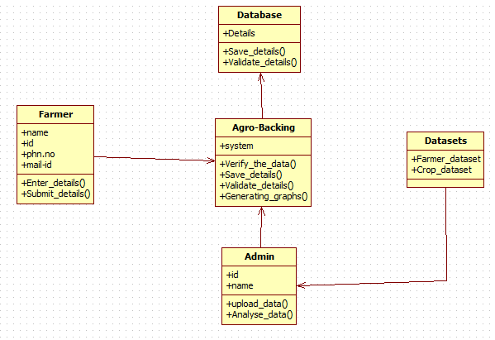

Fig:5.2.1 Class Diagram

Description of class diagram

In this diagram, there are mainly 6 classes presented with their attributes and operations and also the constraints imposed on the system. All the classes are connected my means of direct association.

To list out responsibilities of the classes:

Database:

1.save details

2.validate details

Agro backing:

1.verifying the data

2.save details

3.validate details

4.generating graphs

Farmer:

1.enter details

2.submit details

Admin:

1.upload data

2. analyse data

**5.2.2 Use case Diagram**

A use case diagram at its simplest is a representation of a user's interaction with the system that shows the relationship between the user and the different use cases in which the user is involved. A use case diagram can identify the different types of users of a system and the different use cases and will often be accompanied by other types of diagrams as well. The use cases are represented by either circles or ellipses.

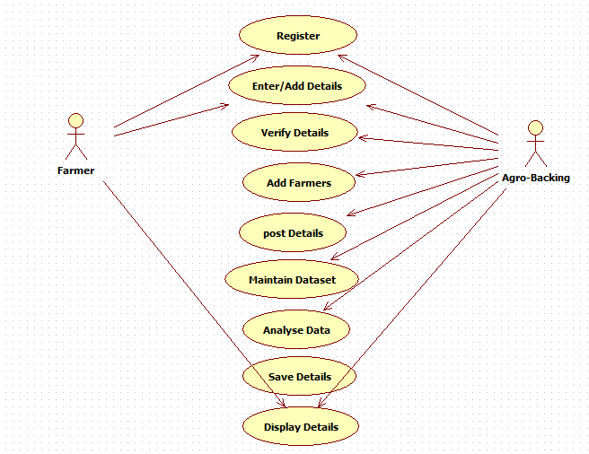

Fig:5.2.2a Use case Diagram (Farmer)

Description:

Use case diagram will represent relation between actors and the use cases. Actors are the users and the use cases are the actions users (Actors) perform. In our project actors are user and system. Here, system is the web interface. Actions between the actor are represented in ellipses. In this use case diagram, there are mainly two actors with their respective use cases. Actors:

1.Farmer

Use cases:

1.Register

2.Enter/Add details

2.Agro backing

Use cases:

1.Register

2.Add/Enter details

3.Verify details

4.Add farmers

5.Post details

6.Maintain dataset

7.Analyse data

8.Save details

9.Display details

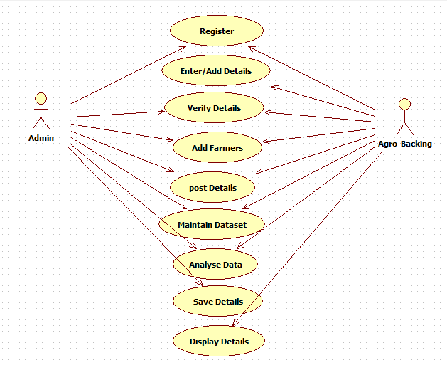

Fig: 5.2.2b Use case Diagram (Admin)

**Description**:

Use case diagram will represent relation between actors and the use cases. Actors are the users and the use cases are the actions users (Actors) perform. In our project actors are user and system. Here, system is the web interface. Actions between the actor are represented in ellipses. In this use case diagram, there are mainly two actors with their respective use cases.

Actors:

1.Admin

Use cases:

1.Register

2.Enter/Add details

3.Verify details

4.Add farmers

5.Post details

6.Maintain dataset

7.Analyse data

8.Save details

2.Agro backing

Use cases:

1.Register

2.Add/Enter details

3.Verify details

4.Add farmers

5.Post details

6.Maintain dataset

7.Analyse data

8.Save details

9.Display details

**5.2.3 SEQUENCE DIAGRAM:**

A sequence diagram shows object interactions arranged in time sequence. It depicts the objects and classes involved in the scenario and the sequence of messages exchanged between the objects needed to carry out the functionality of the scenario. Sequence diagrams are typically associated with use case realizations in the Logical View of the system under development. Sequence diagrams are sometimes called event diagrams or event scenarios

.

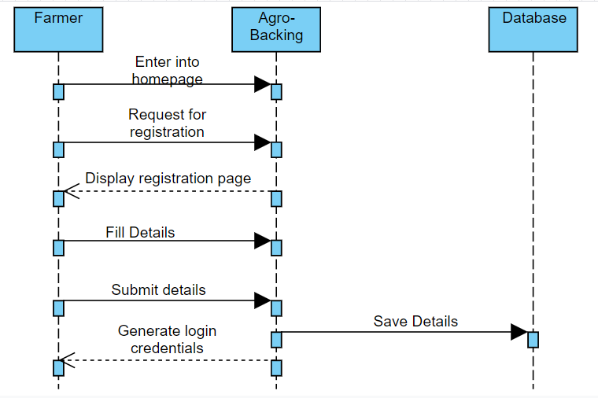

Fig:5.2.3a Sequence Diagram (Registration)

Description:

Sequence diagrams are typically associated with use case realizations in the Logical View of the system under development. It depicts the objects and classes involved in the scenario and the sequence of messages exchanged between the objects needed to carry out the functionality of the scenario. In this sequence diagram, there is an interaction between 3 objects mainly in a timely manner.

Objects:

1.Farmer

2.Agro backing

3.Database

Messages Exchanged:

1.Enter into homepage

2.Request for registration

3.Display registration form

4.Fill details

5.Submit details

6.Save details

7.Generate login credentials

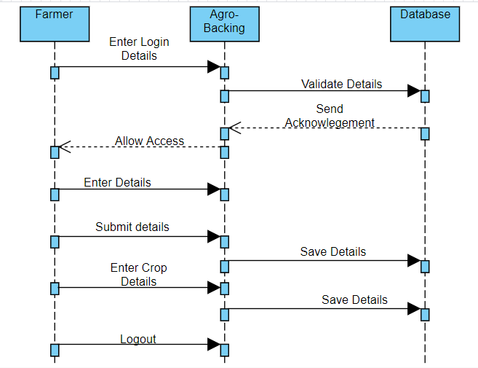

Fig:5.2.3b Sequence Diagram (Farmer Login)

Description:

Sequence diagrams are typically associated with use case realizations in the Logical View of the system under development. It depicts the objects and classes involved in the scenario and the sequence of messages exchanged between the objects needed to carry out the functionality of the scenario. In this sequence diagram, there is an interaction between 3 objects mainly in a timely manner.

Objects:

1.Farmer

2.Agro backing

3.Database

Messages Exchanged:

1.Enter login details

2.Validate details

3.Allow access

4.Enter details

5.Submit details

6.Save details

7.Enter crop details

8.Save crop details

9.Logout

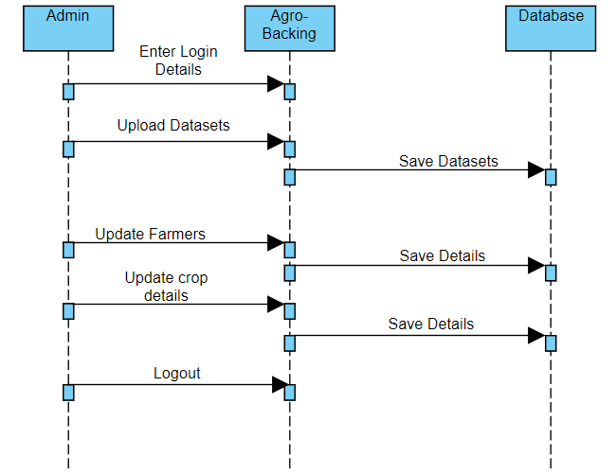

Fig:5.2.3c Sequence Diagram (Admin)

**Description:**

Sequence diagrams are typically associated with use case realizations in the Logical View of the system under development. It depicts the objects and classes involved in the scenario and the sequence of messages exchanged between the objects needed to carry out the functionality of the scenario. In this sequence diagram, there is an interaction between 3 objects mainly in a timely manner.

Objects:

1.Admin

2.Agro backing

3.Database

Messages Exchanged:

1.Enter login details

2.Validate details

3.Allow access

4.Upload datasets

5.Submit datasets

6.Upload farmers

7.Save details

8.Upload crop details

9.Save crop details

10.Logout

**5.2.4 ACTIVITY DIAGRAM:**

Activity diagram is another important diagram in UML to describe the dynamic aspects of the system. Activity diagram is basically a flowchart to represent the flow from one activity to another activity. The activity can be described as an operation of the system. The basic purposes of activity diagrams are similar to other four diagrams. It captures the dynamic behaviour of the system. Other four diagrams are used to show the message flow from one object to another but activity diagram is used to show message flow from one activity to another. Activity is a particular operation of the system. Activity diagrams are not only used for visualizing the dynamic nature of a system, but they are also used to construct the executable system by using forward and reverse engineering techniques. The only missing thing in the activity diagram is the message part

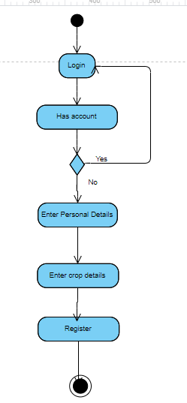

Fig:5.2.4a Activity Diagram (Farmer)

**Description:**

In this activity diagram, the farmer activities are shown as flow chart. The flow of activities is done to register in agro backing.

These flows of activities include:

1.Login (with automatically generated credentials)

2.Enter (if credentials are correct)

3.Enter again (if credentials are incorrect)

4.Enter personal details

5.Enter crop details

6.Registration done

7.Logout(if needed)

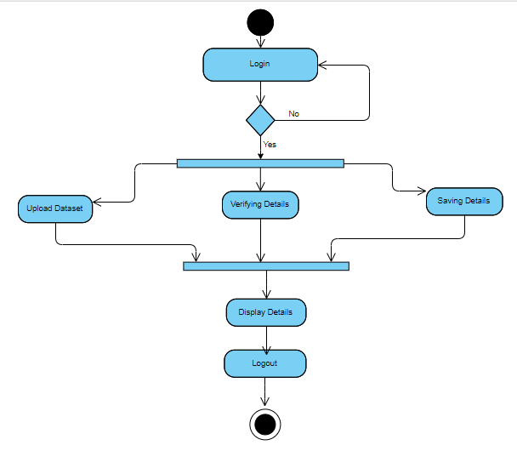

Fig:5.2.4b Activity Diagram (Admin)

**Description:**

In this activity diagram, the flow of activities is done for admin to enter or update the database.

The flow of activities includes:

1.Login

2.Enter (if credentials are correct)

3.Enter again (if credentials are incorrect)

4.

1.Upload dataset

2.Verify details

3.Save details

5.Display details

6.Logout

**5.2.5 STATE-CHART DIAGRAM:**

The name of the diagram itself clarifies the purpose of the diagram and other details. It describes different states of a component in a system. The states are specific to a component/object of a system. A State chart diagram describes a state machine. State machine can be defined as a machine which defines different states of an object and these states are controlled by external or internal events.

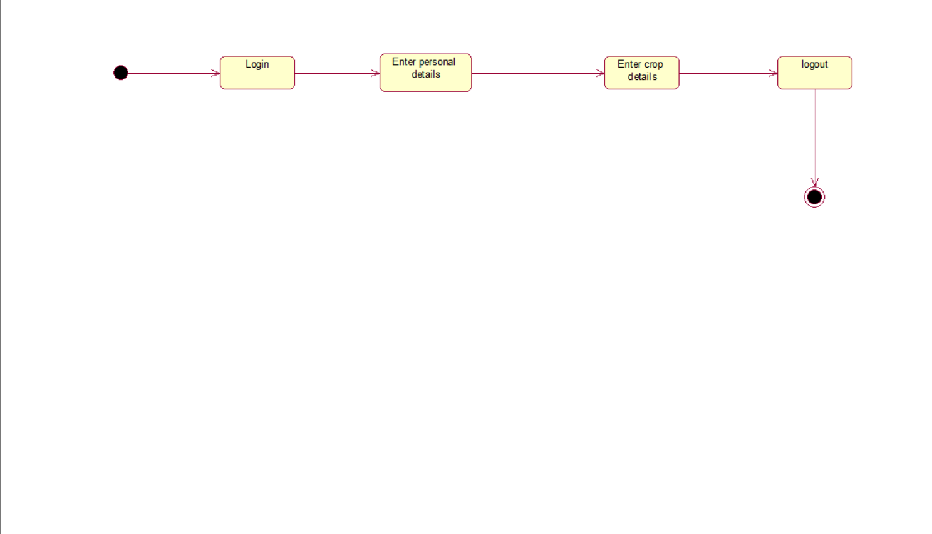

Fig 5.2.5a State Chart Diagram (Farmer)

Description:

A State chart diagram describes a state machine. State machine can be defined as a machine which defines different states of an object and these states are controlled by external or internal events. In this state chart diagram, the states to login or register a farmer is shown.

The states include:

1.Login

2.Enter personal details

3.Enter crop details

4.Logout

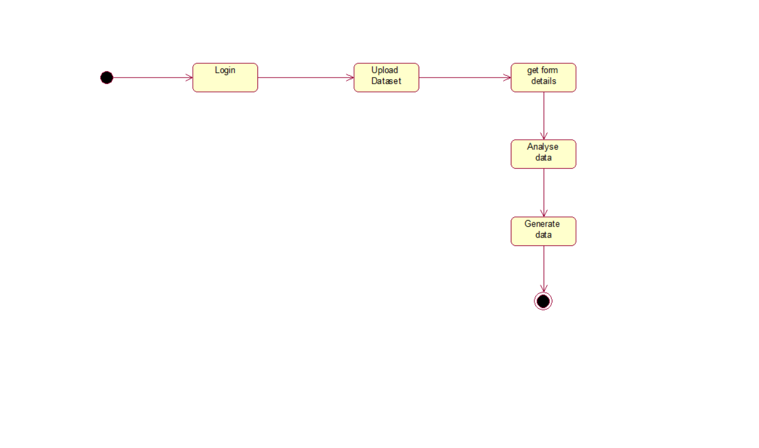

Fig:5.2.5b State Chart Diagram (Admin)

**Description**:

A State chart diagram describes a state machine. State machine can be defined as a machine which defines different states of an object and these states are controlled by external or internal events. In this state chart diagram, the states to login or update details for admin is shown.

The states include:

1.Login

2.Upload dataset

3.Get form details

4.Analyse data

5.Generate data

6.Logout

**5.2.6 COLLABORATION DIAGRAM:**

A collaboration diagram, also called a communication diagram or interaction diagram, is an illustration of the relationships and interactions among software objects in the Unified Modelling Language (UML). The relationships between the objects are shown as lines connecting the rectangles.

**Fig 5.2.6 Collaboration Diagram**

**Description**: These shows the relation between objects

**5.2.7 COMPONENT DIAGRAM:**

In Unified Modelling Language, a component diagram depicts how components are wired together to form larger components or software systems. They are used to illustrate the structure of arbitrarily complex systems.

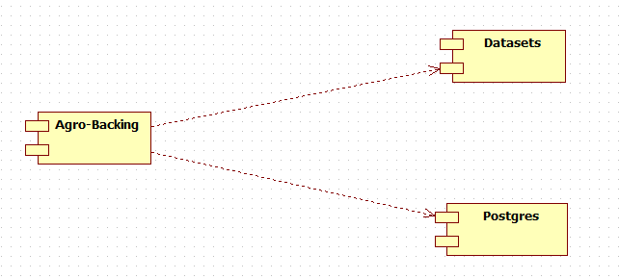 Fig 5.2.7 Component Diagram

**Description:**

In this component diagram, it shows how the different components are connected together. These diagrams are used to illustrate the structure of arbitrarily complex systems. The components are connected by means of dependency.

The components include:

1.Agro backing

2.Datasets

3.Postgres(database)

**5.2.8 DEPLOYMENT DIAGRAM:**

A deployment diagram in the Unified Modelling Language models the physical deployment of artefact’s on nodes. To describe a web site, for example, a deployment diagram would show what hardware components exist, what software components run on each node, and how the different pieces are connected**.**

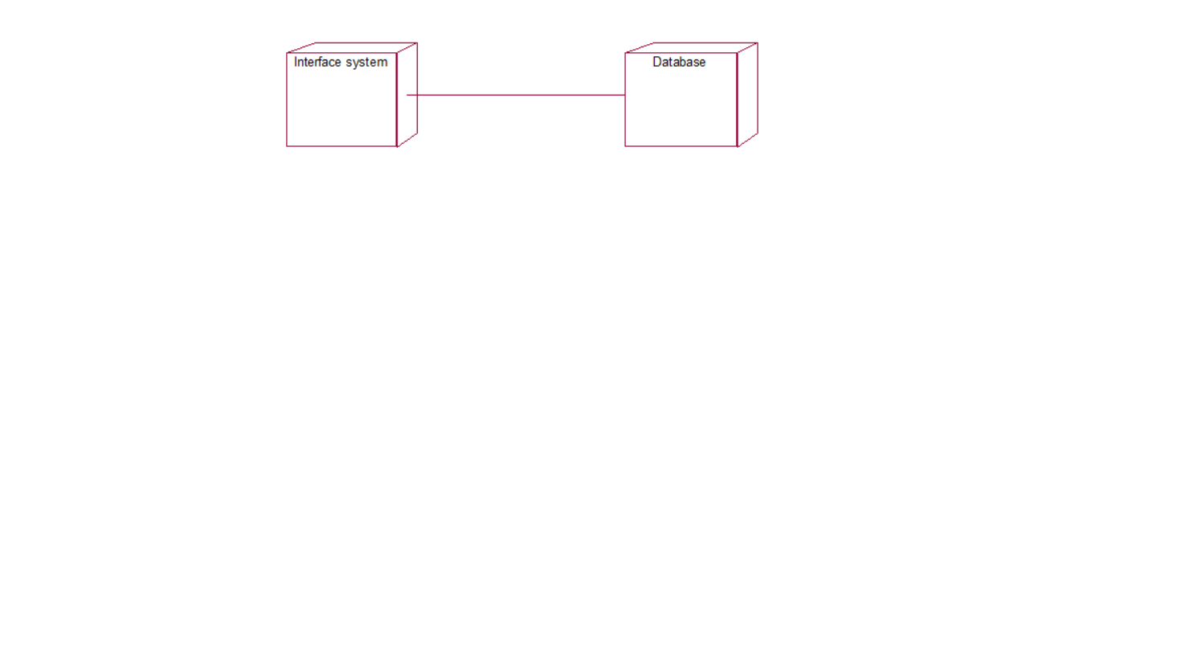

Fig:5.2.8 Deployment Diagram

**Description:**

In this deployment diagram, it shows how the physical deployment of artefact’s on nodes. The physical elements of the system is connected by means of association.

The physical elements include:

1.Interface system

2.Database

**CHAPTER-6**

**SOFTWARE ENVIRONMENT**

**6.1 PYTHON:**

* Python laid its foundation in the late 1980s.
* The implementation of Python was started in the December 1989 by Guido Van Rossum at CWI in Netherland.
* In February 1991, van Rossum published the code (labelled version 0.9.0) to outsources.
* In 1994, Python 1.0 was released with new features like: lambda, map, filter, and reduce.
* Python 2.0 added new features like: list comprehensions, garbage collection system.
* On December 3, 2008, Python 3.0 (also called "Py3K") was released. It was designed to rectify fundamental flaw of the language.
* ABC programming language is said to be the predecessor of Python language which was capable of Exception Handling and interfacing with Amoeba Operating System.
* Python is influenced by following programming languages:
* ABC language.
* Modula-3

**6.2 FEATURES OF PYTHON:**

* Expressive Language

Python language is more expressive means that it is more understandable and readable.

* Interpreted Language

Python is an interpreted language i.e. interpreter executes the code line by line at a time. This makes debugging easy and thus suitable for beginners.

* Cross-platform Language

Python can run equally on different platforms such as Windows, Linux, Unix and Macintosh etc. So, we can say that Python is a portable language.

* Free and Open Source

Python language is freely available at official web address. The source-code is also available. Therefore, it is open source.

* Object-Oriented Language

Python supports object-oriented language and concepts of classes and objects come into existence.

* Extensible

It implies that other languages such as C/C++ can be used to compile the code and thus it can be used further in our python code.

* Large Standard Library

Python has a large and broad library and provides rich set of module and functions for rapid application development.

* GUI Programming Support

Graphical user interfaces can be developed using Python.

* Integrated

It can be easily integrated with languages like C, C++, JAVA etc.

**6.3 Installing Python (Environment Set-up)**

Python can be obtained from the **Python Software Foundation** website at [python.org](https://www.python.org/). Typically, that involves downloading the appropriate **installer** for your operating system and running it on your machine.

Some operating systems, notably Linux, provide a **package manager** that can be run to install Python.

On macOS, the best way to install Python 3 involves installing a package manager called **Homebrew**.

On mobile operating systems like Android and iOS, you can install apps that provide a Python programming environment.

Alternatively, there are several websites that allow you to access a Python interpreter online without installing anything on your computer at all.

In this Python installation guide, you’ll see step by step how to set up a working Python 3 distribution on Windows, macOS, Linux, iOS, and Android.

**Windows:**

It is highly unlikely that your Windows system shipped with Python already installed. Windows systems typically do not. Fortunately, installing does not involve much more than downloading the Python installer from the [python.org website](https://www.python.org/) and running it.

**Step 1: Download the Python 3 Installer**

Open a browser window and navigate to the [Download page for Windows](https://www.python.org/downloads/windows/) at [python.org](https://www.python.org/).

Underneath the heading at the top that says **Python Releases for Windows**, click on the link for the **Latest Python 3 Release - Python 3.x.x**. (As of this writing, the latest is Python 3.6.5.)

**Step 2: Run the Installer**

Once you have chosen and downloaded an installer, simply run it by double-clicking on the downloaded file. A dialog should appear that looks something like this:

[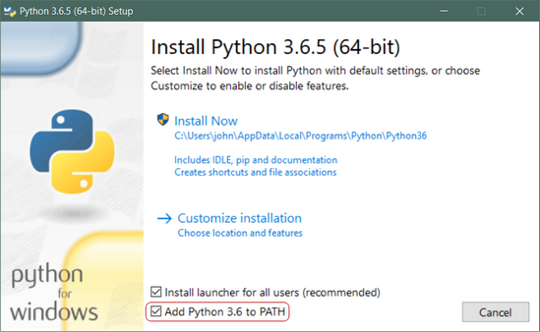](https://files.realpython.com/media/win-install-dialog.40e3ded144b0.png)

Then just click **Install Now**. That should be all there is to it. A few minutes later you should have a working Python 3 installation on your system.

Windows Subsystem for Linux (WSL)

If you are running Windows 10 Creators or Anniversary Update, you actually have another option for installing Python. These versions of Windows 10 include a feature called the **Windows Subsystem for Linux,** which allows you to run a Linux environment directly in Windows, unmodified and without the overhead of a virtual machines.

Once you have installed the Linux distribution of your choice, you can install Python 3 from a Bash console window, just as you would if you were running that Linux distribution natively. (See below.)

**Linux:**

There is a very good chance your Linux distribution has Python installed already, but it probably won’t be the latest version, and it may be Python 2 instead of Python 3.

To find out what version(s) you have, open a terminal window and try the following commands:

python --version

python2 --version

python3 --version

One or more of these commands should respond with a version, as below:

$ python3 --version

Python 3.6.5

If the version shown is Python 2.x.x or a version of Python 3 that is not the latest (3.6.5 as of this writing), then you will want to install the latest version. The procedure for doing this will depend on the Linux distribution you are running.

Note that it is frequently easier to use a tool called pyenv to manage multiple Python versions on Linux. To learn more about it, see our article [here](https://realpython.com/python-virtual-environments-a-primer/#using-different-versions-of-python).

**Ubuntu:**

Depending on the version of the Ubuntu distribution you run, the Python install instructions vary. You can determine your local Ubuntu version by running the following command:

$ lsb_release -a

No LSB modules are available.

Distributor ID: Ubuntu

Description: Ubuntu 16.04.4 LTS

Release: 16.04

Codename: xenial

Depending on the version number you see under Release in the console output, follow the instructions below:

**Ubuntu 17.10, Ubuntu 18.04** (and above) come with Python 3.6 by default. You should be able to invoke it with the command python3.

**Ubuntu 16.10 and 17.04** do not come with Python 3.6 by default, but it is in the Universe repository. You should be able to install it with the following commands:

$ sudo apt-get update

$ sudo apt-get install python3.6

You can then invoke it with the command python3.6.

If you are using **Ubuntu 14.04 or 16.04**, Python 3.6 is not in the Universe repository, and you need to get it from a Personal Package Archive (PPA). For example, to install Python from the [“deadsnakes” PPA](https://launchpad.net/~deadsnakes/+archive/ubuntu/ppa), do the following:

$ sudo add-apt-repository ppa:deadsnakes/ppa

$ sudo apt-get update

$ sudo apt-get install python3.

**CHAPTER-7**

**DATABASE**

**7.1 PostgreSQL Database:**

PostgreSQL is a powerful, open source object-relational database system that uses and extends the SQL language combined with many features that safely store and scale the most complicated data workloads. The origins of PostgreSQL date back to 1986 as part of the [**POSTGRES**](https://www.postgresql.org/docs/current/history.html) project at the University of California at Berkeley and has more than 30 years of active development on the core platform.

PostgreSQL has earned a strong reputation for its proven architecture, reliability, data integrity, robust feature set, extensibility, and the dedication of the open source community behind the software to consistently deliver performant and innovative solutions. PostgreSQL runs on [**all major operating systems**](https://www.postgresql.org/download/), has been [**ACID**](https://en.wikipedia.org/wiki/ACID)-compliant since 2001, and has powerful add-ons such as the popular [**PostGIS**](https://postgis.net/) geospatial database extender. It is no surprise that PostgreSQL has become the open source relational database of choice for many people and organizations.

[**Getting started**](https://www.postgresql.org/docs/current/tutorial.html) with using PostgreSQL has never been easier - pick a project you want to build, and let PostgreSQL safely and robustly store your data.

## Why use PostgreSQL

PostgreSQL comes with [**many features**](https://www.postgresql.org/about/featurematrix/) aimed to help developers build applications, administrators to protect data integrity and build fault-tolerant environments, and help you manage your data no matter how big or small the dataset. In addition to being [**free and open source**](https://www.postgresql.org/about/license/), PostgreSQL is highly extensible. For example, you can define your own data types, build out custom functions, even write code from [**different programming languages**](https://www.postgresql.org/docs/current/xplang.html) without recompiling your database!

PostgreSQL tries to conform with the [**SQL standard**](https://www.postgresql.org/docs/current/features.html) where such conformance does not contradict traditional features or could lead to poor architectural decisions. Many of the features required by the SQL standard are supported, though sometimes with slightly differing syntax or function. Further moves towards conformance can be expected over time. As of the version 12 release in October 2019, PostgreSQL conforms to at least 160 of the 179 mandatory features for SQL:2016 Core conformance. As of this writing, no relational database meets full conformance with this standard.

Below is an inexhaustive list of various features found in PostgreSQL, with more being added in every [**major release**](https://www.postgresql.org/developer/roadmap/):

* **Data Types**
  + Primitives: Integer, Numeric, String, Boolean
  + Structured: Date/Time, Array, Range, UUID
  + Document: JSON/JSONB, XML, Key-value (Hstore)
  + Geometry: Point, Line, Circle, Polygon
  + Customizations: Composite, Custom Types
* **Data Integrity**
  + UNIQUE, NOT NULL
  + Primary Keys
  + Foreign Keys
  + Exclusion Constraints
  + Explicit Locks, Advisory Locks
* **Concurrency, Performance**
  + Indexing: B-tree, Multicolumn, Expressions, Partial
  + Advanced Indexing: Gist, SP-Gist, KNN Gist, GIN, BRIN, Covering indexes, Bloom filters
  + Sophisticated query planner / optimizer, index-only scans, multicolumn statistics
  + Transactions, Nested Transactions (via save points)
  + Multi-Version concurrency Control (MVCC)
  + Parallelization of read queries and building B-tree indexes
  + Table partitioning
  + All transaction isolation levels defined in the SQL standard, including Serializable
  + Just-in-time (JIT) compilation of expressions
* **Reliability, Disaster Recovery**
  + Write-ahead Logging (WAL)
  + Replication: Asynchronous, Synchronous, Logical
  + Point-in-time-recovery (PITR), active standbys
  + Tablespaces
* **Security**
  + Authentication: GSSAPI, SSPI, LDAP, SCRAM-SHA-256, Certificate, and more
  + Robust access-control system
  + Column and row-level security
  + Multi-factor authentication with certificates and an additional method
* **Extensibility**
  + Stored functions and procedures
  + Procedural Languages: PL/PGSQL, Perl, Python (and many more)
  + SQL/JSON path expressions
  + Foreign data wrappers: connect to other databases or streams with a standard SQL interface
  + Customizable storage interface for tables
  + Many extensions that provide additional functionality, including PostGIS.
* **Internationalisation, Text Search**
  + Support for international character sets, e.g. through ICU collations
  + Case-insensitive and accent-insensitive collations
  + Full-text search

**7.2 Advantages of PostgreSQL:**

**7.2.1Open-Source-DBMS:**

Only PostgreSQL provides enterprise-class performance and functions among current Open Source DBMS with no end of development possibilities. Also, PostgreSQL users can directly participate in the community and post and share inconveniences and bugs.

**7.2.2 Diverse Community**

One of the characteristics of PostgreSQL is that there are a wide variety of communities. Regarding PostgreSQL as Open Source DBMS, users themselves can develop modules and propose the module to the community. The development possibility is superiorly high with collecting opinions from its own global community organized with all different kinds of people. Collective Intelligence, as some might call it, facilitates transmission of indigenous knowledge greatly within the communities.

**7.3.3 Function**

SQL functions called ‘Store Procedure’ can be used for server environment. Also, we support languages similar to PL/SQL in Oracle such as PL/pgSQL, PL/Python, PL/Perl, C/C++, and PL/R.

**7.3.4 ACID and Transaction**

PostgreSQL support ACID (Atomicity, Consistency, Isolation, Durability).

**7.3.5 Diverse indexing techniques**

PostgreSQL not only provides B+ tree index techniques, but various kinds of techniques such as GIN(Generalized Inverted Index), and GiST(Generalized Search Tree), etc. as well.

**7.3.6 Flexible Full-text search**

Full-text search is available when searching for strings with execution of vector operation and string search.

**7.3.7 Diverse kinds of replication**

PostgreSQL supports a variety of replication methods such as Streaming Replication, Stony-I, and cascading.

**7.3.8 Diversified extension functions**

PostgreSQL supports different kinds of techniques for geographic data storage such as PostGIS, Key-Value Store, and DB Link.

.

**7.4 Database Tables**

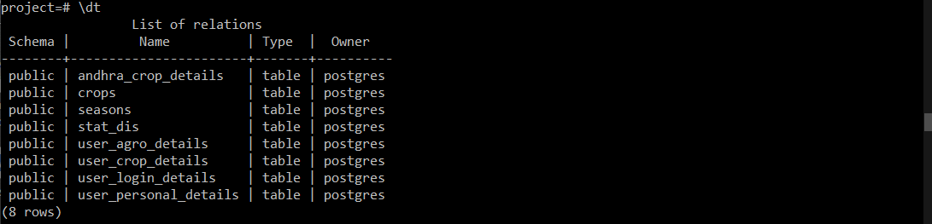

Fig:7.4.1 Relations List

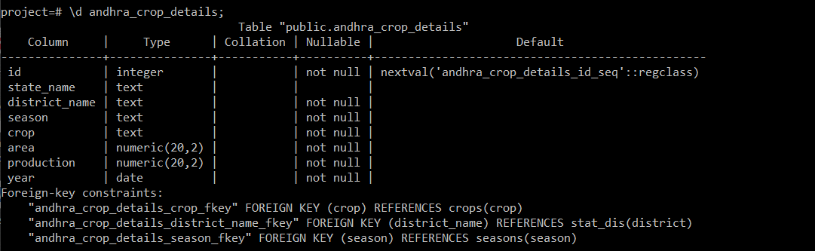

Fig:7.4.2 Andhra Crop Details Schema

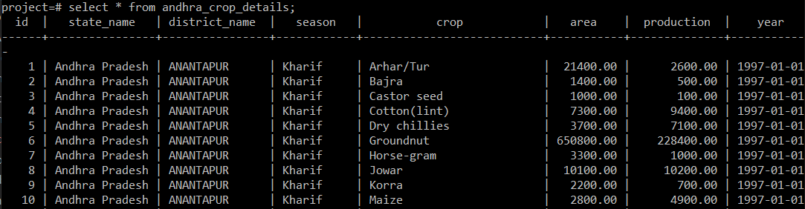

Fig:7.4.3 Andhra Crops Data

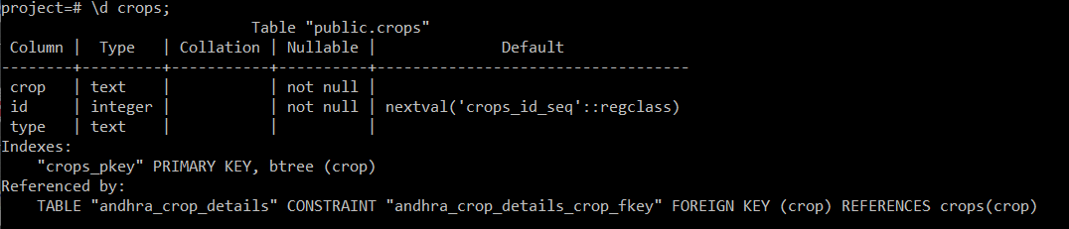

Fig:7.4.4 Crops Type Schema

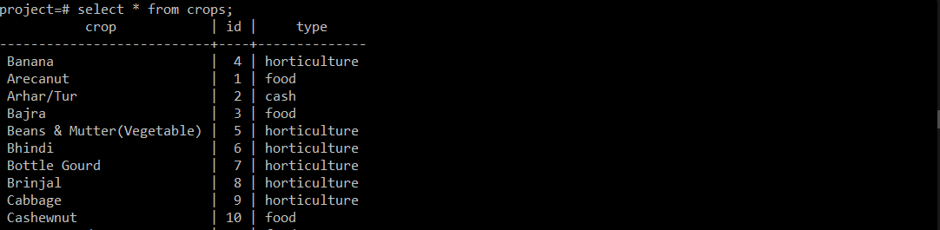

Fig:7.4.5 Crops Type Data

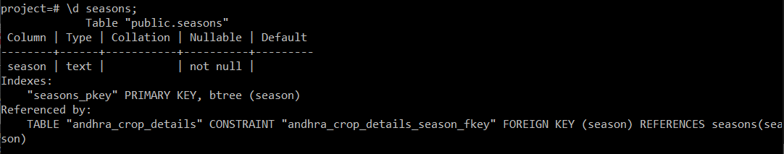

Fig:.7.4.6 Seasons Schema

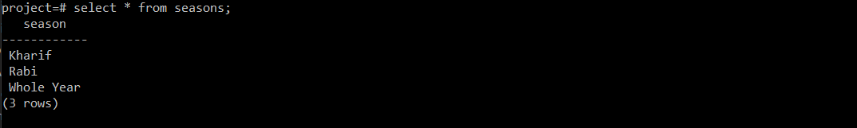

Fig:7.4.7 Seasons

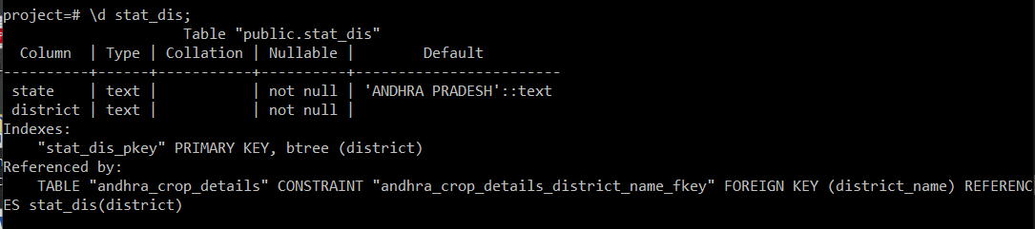

Fig:7.4.8 Statewise Districts Schema

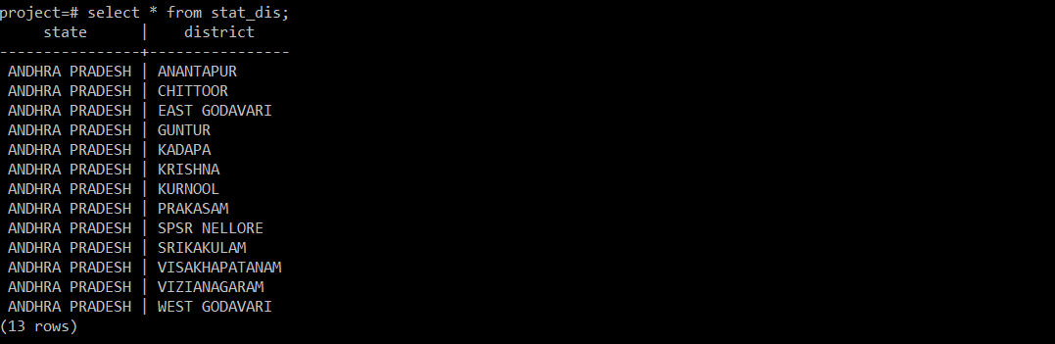

Fig:7.4.9 State wise Districts

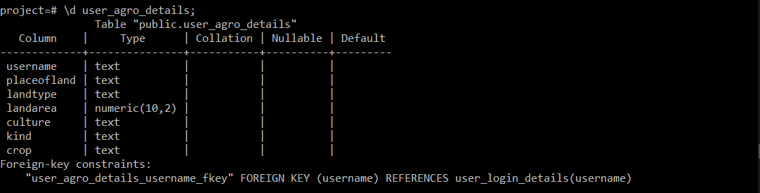

Fig:7.4.10 User Agro Details Schema

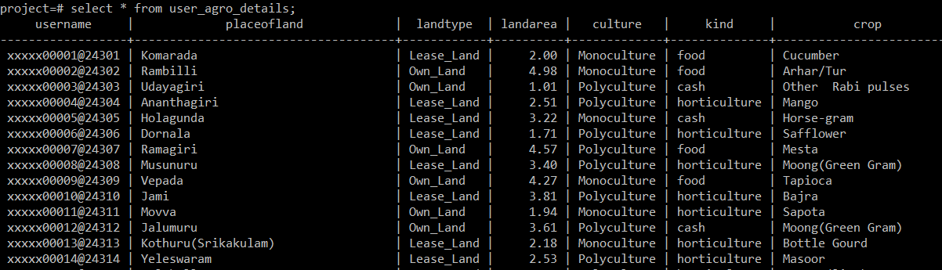

. Fig:7.4.11 User Agriculture Details

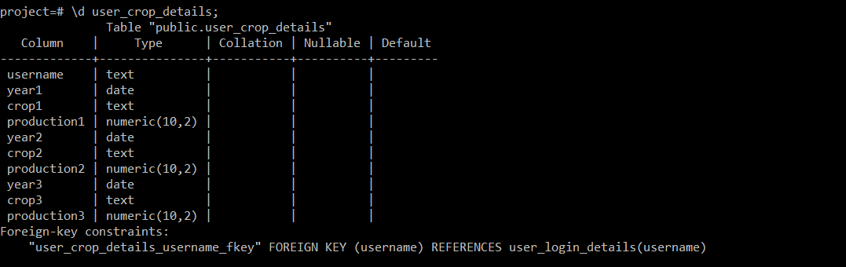

Fig:7.4.12 User Crop Details Schema

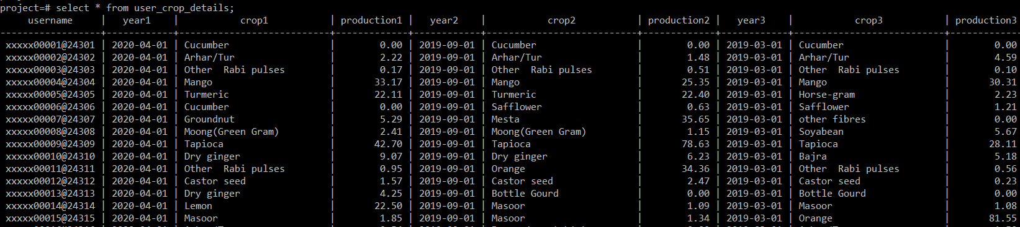

Fig:7.4.13 User Crop Details

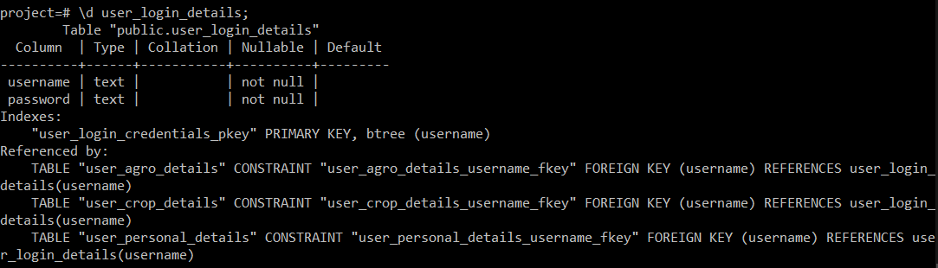

Fig:7.4.14 User Login Details Schema

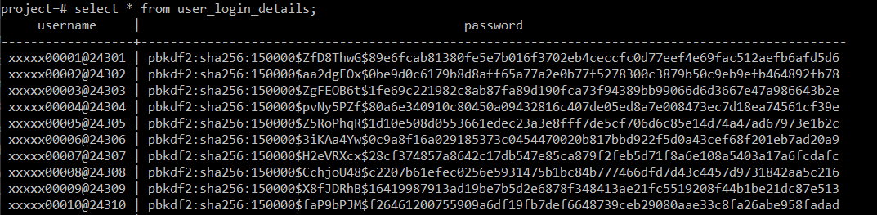

Fig:7.4.15 User Login Details

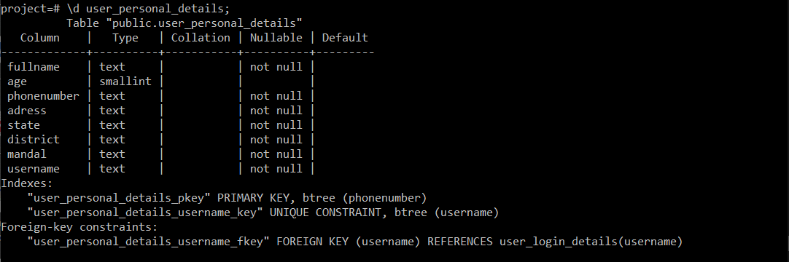

Fig:7.4.16 User Personal Details Schema

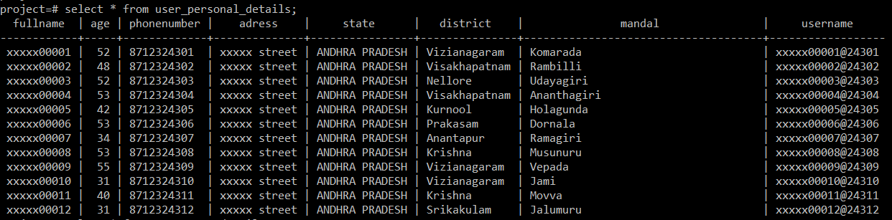

Fig:7.4.17 User Personal Details

**CHAPTER-8**

**SYSTEM IMPLEMENTATION**

**8.1 MODULE SPECIFICATION**

**PYTHON:**

Python is a popular platform used for research and development of production systems. It is a vast language with number of modules, packages and libraries that provides multiple ways of achieving a task.

Python and its libraries like NumPy, SciPy, Scikit-Learn, and Matplotlib are used in data science and data analysis. They are also extensively used for creating scalable machine learning algorithms. Python implements popular machine learning techniques such as Classification, Regression, Recommendation, and Clustering.

**Libraries and Packages:**

To understand machine learning, you need to have basic knowledge of Python programming. In addition, there are a number of libraries and packages generally used in performing various machine learning tasks as listed below:

* NumPy - is used for its N-dimensional array objects
* Pandas – is a data analysis library that includes data frames
* Matplotlib – is 2D plotting library for creating graphs and plots
* Scikit-learn - the algorithms used for data analysis and data mining tasks
* Seaborn – a data visualization library based on matplotlib Installation

**Installation:**

You can install software for machine learning in any of the two methods as discussed here:

**Method 1:**

Download and install Python separately from python.org on various operating systems as explained below:

To install Python after downloading, double click the .exe (for Windows) or .pkg (for Mac) file and follow the instructions on the screen.

For Linux OS, check if Python is already installed by using the following command at the prompt:

If Python 3.7 or later is not installed, install Python with the distribution's package

manager. Note that the command and package name varies. On Debian derivatives such as Ubuntu, you can use apt:

Now, open the command prompt and run the following command to verify that Python is

installed correctly:

Similarly, we can download and install necessary libraries like numpy, matplotlib etc.

individually using installers like pip. For this purpose, you can use the commands shown here:

**Method 2:**

Alternatively, to install Python and other scientific computing and machine learning packages simultaneously, we should install Anaconda distribution. It is a Python implementation for Linux, Windows and OSX, and comprises various machine learning packages like NumPy, Scikit-learn, and matplotlib. It also includes **Jupyter Notebook**, an interactive Python environment. We can install Python 2.7 or any 3.x version as per our

To download the free Anaconda Python distribution from Continuum Analytics, you can do the following:

Visit the official site of Continuum Analytics and its download page. Note that the installation process may take 15-20 minutes as the installer contains Python, associated packages, a code editor, and some other files. Depending on your operating system, choose the installation process as explained here:

For Windows:

Select the Anaconda for Windows section and look in the column with Python 2.7 or

* x. You can find that there are two versions of the installer, one for 32-bit Windows, and one for 64-bit Windows. Choose the relevant one.

**For Mac OS:** Scroll to the Anaconda for OS X section. Look in the column with Python 2.7 or 3.x. Note that here there is only one version of the installer: the 64-bit version.

**For Linux OS:** We select the "Anaconda for Linux" section. Look in the column with Python 2.7 or 3.x.

Note that you have to ensure that Anaconda’s Python distribution installs into a single directory, and does not affect other Python installations, if any, on your system.

To work with graphs and plots, we will need these Python library packages: **matplotlib**

and **seaborn.**

If you are using Anaconda Python, your system already has numpy, matplotlib, pandas, seaborn, etc. installed. We start the Anaconda Navigator to access either **Jupyter Note book** or Spyder **IDE** of python.

After opening either of them, type the following commands:

Now, we need to check if installation is successful. For this, go to the command line and

type in the following command:

**8.2 SAMPLE CODE**

**App.py**

from flask import Flask,render_template,url_for,request,jsonify,redirect,flash

import json

from db_connect import connect

from db_user import user_details

from panda_data import data

from db_farmer_search import send_details,farmer_info

from sms import sendSms

from login_verify import login_verify

from db_get import after_register

from analysis import analysis

app=Flask(__name__)

app.config["CACHE_TYPE"] = "null"

app.config['SEND_FILE_MAX_AGE_DEFAULT']=1

app.secret_key=b'd5d7cd4eb3af4fd2490e33f585a9bf0171e3a35d4fbd027f'

""" creating different routes for different webpages """

@app.route('/')

def home():

    return render_template('home.html')

@app.route('/login')

def login():

    return render_template('login.html')

@app.route('/about')

def aboutus():

    return render_template('aboutus.html')

@app.route('/farmerinfo',methods=['POST','GET'])

def farmerinfo():

    username=request.form['username']

    print(username)

    result=farmer_info(username)

    result[0][4]=result[0][4].title()

    print(result)

    stat1,stat2,stat3,stat41,stat42=analysis(result)

    print(stat1,stat2,stat3,stat41,stat42)

    return render_template('farmerinfo.html',result=result,stat1=stat1,stat2=stat2,stat3=stat3,stat41=stat41,stat42=stat42)

@app.route('/farmersearch',methods=['POST','GET'])

def farmersearch():

    print(request.form)

    result=send_details(request.form)

    return render_template('farmerlist.html',result=result)

@app.route('/services',methods=['POST','GET'])

def services():

    with open('datasets/dat.json','r') as f:

        datalist=json.load(f)

    dist=list(datalist.keys())

    crop=data()

    crops=crop['crop'].unique()

    return render_template('farmersearch.html',datalist=datalist,districts=dist,crops=list(crops))

@app.route('/registersubmit',methods=['POST'])

def registersubmit():

    c=request.form

    print(c)

    username=user_details(dict(c)

    conn=connect()

    details=after_register(conn,username)

    flash(details,'success')

    return redirect(url_for('register'))

@app.route('/contact')

def contactus():

    return render_template('contactus.html')

@app.route('/register',methods=['GET'])

def register():

    with open('datasets/dat.json','r') as f:

        datalist=json.load(f)

    dist=list(datalist.keys())

    with open("datasets/arable.json") as f:

        crops=json.load(f)

    print(type(crops))

    values=list(crops.values())

    crops1=values[0]+values[1]+values[2]+values[3]

    return render_template('register.html',datalist=datalist,districts=dist,crop=crops,crops1=crops1)

@app.route('/arable',methods=['GET','POST'])

def arable():

    with open('datasets/arable.json') as f:

        crops=json.load(f)

    return render_template('arable.html',datalist=crops)

@app.route('/view')

def viewProfile():

    return render_template('login.html')

@app.route('/notify',methods=['GET','POST'])

def notify():

    data=request.form

    # sendSms(dict(data))

    return jsonify({"msg":"your response is sent"})

@app.route('/login_verify',methods=['GET','POST'])

def verify():

    data=request.form

    print(data)

    result=login_verify(dict(data))

    print(result)

    if result==False:

        return jsonify({"msg":"your response is sent"})

    else:

        return render_template('hello.html',result=result)

""" main app calling """

if __name__=="__main__":

    app.run(debug=True)

**db_farmer_search.py**

from db_connect import connect

from db_get import farmer_details,get_user_crop_details,get_user_login_details,get_user_agro_details,get_user_personal_details,get_details_by_location,get_details_by_crop,get_details_by_cost,get_details_by_rl,get_details_by_rc,get_details_by_rlc,get_details_by_lc

import json

conn=connect()

def send_details(args):

    start=args['start']

    end=args['end']

    district=args['district']

    mandal=args['mandal']

    crops=tuple(json.loads(args['crops']))

    # print(type(crops))

    if start==''or start=='0':

        start=None

    if end=='' or end=='0':

        end=None

    if district=='':

        district=None

    if len(crops)==0:

        crops=None

    result=farmer_search(start,end,district,mandal,crops)

    # print(start,end,district,mandal,crops)

    # print(result)

    return(result)

def farmer_search(range1=None,range2=None,district=None,mandal=None,crops=None):

    if range1 and range2 and district and mandal and crops:

        return(get_details_by_rlc(conn,range1,range2,district,mandal,crops))

    elif range1 and range2 and district and mandal:

        return(get_details_by_rl(conn,range1,range2,district,mandal))

    elif range1 and range2 and crops:

        return(get_details_by_rc(conn,range1,range2,crops))

    elif district and mandal and crops:

        return(get_details_by_lc(conn,district,mandal,crops))

    elif range1 and range2:

        return(get_details_by_cost(conn,range1,range2))

    elif district and mandal:

        return(get_details_by_location(conn,district,mandal))

    elif crops:

        return(get_details_by_crop(conn,crops))

    else:

        pass

def farmer_info(username):

    # result=farmer_details(conn,username)

    per=list(map(str,get_user_personal_details(conn,username)))

    agr=list(map(str,get_user_agro_details(conn,username)))

    cro=list(map(str,get_user_crop_details(conn,username)))

    return([per,agr,cro])

if __name__=="__main__":

    # farmer_search(range1=1,range2=2,district="Krishna",mandal="Kankipadu")

    farmer_info('xxxxx00002@24302')

**template.html**

<!DOCTYPE html>

<html lang="en">

<head>

    {% block head %}

    <meta charset="UTF-8">

    <meta name="viewport" content="width=device-width, initial-scale=1.0">

    <link rel="stylesheet" href="{{url_for('static',filename='template.css')}}">

    <link rel="stylesheet" href="https://stackpath.bootstrapcdn.com/bootstrap/4.4.1/css/bootstrap.min.css"

        integrity="sha384-Vkoo8x4CGsO3+Hhxv8T/Q5PaXtkKtu6ug5TOeNV6gBiFeWPGFN9MuhOf23Q9Ifjh" crossorigin="anonymous">

    <script src="https://ajax.googleapis.com/ajax/libs/jquery/3.4.1/jquery.min.js"></script>

    {% block style %}{% endblock style %}

    <title>

        {% block title %}

        {% endblock title %}

    </title>

    {% endblock head %}

</head>

<body>

    <div id="header">

        {% block header %}

        {% endblock header %}

    </div>

    <div id="container">

        {% block container %}

        {% endblock container %}

    </div>

    <div id="footer">

        {% block footer %}

        {% endblock footer %}

    </div>

    {% block jquery %}

    {% block jsfile %} {% endblock jsfile %}

    <script src="https://code.jquery.com/jquery-3.4.1.slim.min.js"

        integrity="sha384-J6qa4849blE2+poT4WnyKhv5vZF5SrPo0iEjwBvKU7imGFAV0wwj1yYfoRSJoZ+n"

        crossorigin="anonymous"></script>

    <script src="https://cdn.jsdelivr.net/npm/popper.js@1.16.0/dist/umd/popper.min.js"

        integrity="sha384-Q6E9RHvbIyZFJoft+2mJbHaEWldlvI9IOYy5n3zV9zzTtmI3UksdQRVvoxMfooAo"

        crossorigin="anonymous"></script>

    <script src="https://stackpath.bootstrapcdn.com/bootstrap/4.4.1/js/bootstrap.min.js"

        integrity="sha384-wfSDF2E50Y2D1uUdj0O3uMBJnjuUD4Ih7YwaYd1iqfktj0Uod8GCExl3Og8ifwB6"

        crossorigin="anonymous"></script>

    {% endblock jquery %}

</body>

</html>

**home.html**

{% extends 'template.html' %}

{% block style %}

<link rel="stylesheet" href="{{url_for('static',filename='home.css')}}">

<link rel="stylesheet" href="{{url_for('static',filename='footer_style.css')}}">

{% endblock style %}

{% block title %}

HomePage

{% endblock title %}

{% block header %}

<header>

    <h1 class="title">

        <center>AGRO-BACKING</center>

    </h1>

    <div class="wrapper">

        <div class="logo">

            <img src="{{url_for('static',filename='log.jpg')}}" class="img-circle" alt="logo" usemap="#logomap">

        </div>

        <ul class="nav-area" id="sai-teja">

            <li><a class="nav-item active" href="{{url_for('home')}}">Home</a></li>

            <li class="nav-item dropdown">

                <a class="nav-link dropdown-toggle" data-toggle="dropdown" href="#" role="button">Profile</a>

                <div class="dropdown-menu">

                    <a class="dropdown-item" href="{{url_for('viewProfile')}}">view</a>

                    <div class="dropdown-divider"></div>

                    <a class="dropdown-item" href="{{url_for('register')}}">register</a>

                </div>

            </li>

            <li><a class="nav-item" href="{{url_for('services')}}">Services</a></li>

            <li><a class="nav-item" href="{{url_for('aboutus')}}">About us</a></li>

            <li><a class="nav-item" href="{{url_for('contactus')}}">Contact us</a></li>

        </ul>

    </div>

    <div class="welcome-text">

        <h1>We are working for farmers</h1>

    </div>

</header>

{% endblock header %}

{% block footer %}

<footer>

    <div class="contact">

        <a href="{{url_for('contactus')}}" title="Contact Us" class="redBgLink">Contact Us</a>

    </div>

    <div class="footer-top">

        <div class="container">

            <div class="row">

                <div class="col-md-3 col-sm-6 col-xs-12 segment-one">

                    <h2>Agro Backing</h2>

                    <p>Agro Backing is for farmers<br /> struggling to cope up with <br /> situations and in need....!

                    </p>

                </div>

                <div class="col-md-3 col-sm-6 col-xs-12 segment-two">

                    <h2>Useful links</h2>

                    <ul>

                        <li><a href="main.html">Home</a></li>

                        <li><a href="prof.html">Profile</a></li>

                        <li><a href="about.html">About us </a></li>

                    </ul>

                </div>

                <div class="col-md-3 col-sm-6 col-xs-12 segment-three">

                    <h2>Follow us on</h2>

                    <p>Please follow us on our social media pages in order to keep updated.</p>

                    <a href="#"><i class="fa fa-facebook faIcon"></i></a>

                    <a href="#"><i class="fa fa-twitter faIcon"></i></a>

                    <a href="#"><i class="fa fa-linkedin faIcon"></i></a>

                </div>

            </div>

        </div>

    </div>

</footer>

{% endblock footer %}

**login.html**

<html lang="en">

<head>

    <meta charset="utf-8">

    <meta name="viewport" content="width=device-width, initial-scale=1">

    <script src="https://ajax.googleapis.com/ajax/libs/jquery/3.4.1/jquery.min.js"></script>

    <link rel="stylesheet" href="https://stackpath.bootstrapcdn.com/bootstrap/4.4.1/css/bootstrap.min.css"

        integrity="sha384-Vkoo8x4CGsO3+Hhxv8T/Q5PaXtkKtu6ug5TOeNV6gBiFeWPGFN9MuhOf23Q9Ifjh" crossorigin="anonymous">

    <link rel="stylesheet" href="{{url_for('static',filename='login.css')}}">

    <title>

        Login form

    </title>

</head>

<body>

    <header>

        <h1 class="title">

            <center>AGRO-BACKING</center>

        </h1>

        <div class="wrapper">

            <div class="logo">

                <img src="{{url_for('static',filename='log.jpg')}}" class="img-circle" alt="logo" usemap="#logomap">

            </div>

            <ul class="nav-area" id="sai-teja">

                <li><a class="nav-item active" href="{{url_for('home')}}">Home</a></li>

                <li class="nav-item dropdown">

                    <a class="nav-link dropdown-toggle" data-toggle="dropdown" href="#" role="button">Profile</a>

                    <div class="dropdown-menu">

                        <a class="dropdown-item" href="{{url_for('viewProfile')}}">view</a>

                        <div class="dropdown-divider"></div>

                        <a class="dropdown-item" href="{{url_for('register')}}">register</a>

                    </div>

                </li>

                <li><a class="nav-item" href="{{url_for('services')}}">Services</a></li>

                <li><a class="nav-item" href="{{url_for('aboutus')}}">About us</a></li>

                <li><a class="nav-item" href="{{url_for('contactus')}}">Contact us</a></li>

            </ul>

        </div>

    </header>

    <div id="main">

        <form class="form">

            <div class="field">

                <label for="email"></label><b>Username</b></label>

                <input type="text" placeholder="Enter username" name="email" class="username" required>

            </div>

            <div class="field">

                <label for="psw" id='pass'><b>Password</b></label>

                <input type="password" placeholder="Enter Password" name="psw" class="password" required>

            </div>

            <div class="buttons">

                <button type="submit" class="btn btn-primary" id="view">View</button>

                <a href="{{url_for('register')}}" class="new-user"><button type="button"

                        class="btn btn-primary ">Register(newuser)</button></a>

            </div>

        </form>

    </div>

    <div class="blank1">

        <div class="blank"></div>

    </div>

</body>

</html>

**Home.css**

*

{

    margin: 0;

    padding: 0;

}

html, body {

    max-width: 100%;

    overflow-x: hidden;

    background-color: rgba(0,0,0);

  }

#footer{

  font-family: Georgia, 'Times New Roman', Times, serif;

  text-align: center;

  padding-top: 1em;

  background-color: rgba(0,0,0);

  min-height: 100px;

}

#footer li{

  list-style-type: none;

}

#footer li > a{

  color: black;

  list-style-type: none;

  padding: 5px 20px;

  font-family: poppins;

  font-size: 14px;

}

.wrapper

{

    width: 100%;

    padding-right: 100px;

    margin:auto;

    position: fixed;

    top: 0em;

    z-index: 1;

}

header

{

    background: linear-gradient(rgba(0, 7, 7, 0.6),rgba(0,0,0,0.1)), url("back1.jpg");

    height: 100vh;

    font-family: Impact, Haettenschweiler, 'Arial Narrow Bold', sans-serif;

    -webkit-background-size:cover;

    background-size: cover;

    background-position: center center;

    position: relative;

}

.nav-area

{

    float: right;

    list-style: none;

    margin-top: 40px;

}

.nav-area li{

    display: inline-block;

  }

div.dropdown-menu{

  background-color: rgba(207, 104, 19, 0.733);

}

.nav-area li a{

    color: #fff;

    text-decoration: none;

    padding: 5px 20px;

    font-family: poppins;

    font-size: 14px;

}

.nav-area li a:hover{

    background: rgba(214, 139, 77, 0.733);

    color: #fff

}

.logo{

  padding: 10px 0px 0px 40px;

}

.logo img{

    width: 100px;

    float: left;

    height: auto;

    border-radius: 5em;

}

.welcome-text{

    position: absolute;

    width: 600px;

    height: 300px;

    margin: 19% 30%;

    text-align: center;

}

.welcome-text h1{

     text-align: center;

    color: rgb(226, 170, 15);

    text-transform: uppercase;

    font-size: 60px;

}

.title{

  position: fixed;

  margin-left: 5em;

  margin-top: 0.4em;

  padding-top: 0.7em;

  z-index: 1;

  max-width: 500px;

  color: rgb(255, 218, 56);

  font-family: Impact, Haettenschweiler, 'Arial Narrow Bold', sans-serif;

  font-weight: bold;

}

**CHAPTER-9**

**TESTING**

The purpose of testing is to discover errors. Testing is the process of trying to discover every conceivable fault or weakness in a work product. It provides a way to check the functionality of components, subassemblies, assemblies and/or a finished product It is the process of exercising software with the intent of ensuring that the Software system meets its requirements and user expectations and does not fail in an unacceptable manner. There are various types of test. Each test type addresses a specific testing requirement.

**9.1 TYPES OF TESTING**

**9.1.1 Unit Testing**

The purpose of testing is to discover errors. Testing is the process of trying to discover every conceivable fault or weakness in a work product. It provides a way to check the functionality of components, subassemblies, assemblies and/or a finished product It is the process of exercising software with the intent of ensuring that the Software system meets its requirements and user expectations and does not fail in an unacceptable manner. There are various types of test. Each test type addresses a specific testing requirement.

**9.1.2 Integration Testing**

Integration tests are designed to test integrated software components to determine if they actually run as one program. Testing is event driven and is more concerned with the basic outcome of screens or fields. Integration tests demonstrate that although the components were individually satisfaction, as shown by successfully unit testing, the combination of components is correct and consistent. Integration testing is specifically aimed at exposing the problems that arise from the combination of components.

**9.1.3 Functional Testing**

Functional tests provide systematic demonstrations that functions tested are available as specified by the business and technical requirements, system documentation, and user manuals. Functional testing is centred on the following items:

Valid Input: identified classes of valid input must be accepted.

Invalid Input : identified classes of invalid input must be rejected.

Functions: identified functions must be exercised.

Output: identified classes of application outputs must be exercised.

Systems/Procedures: interfacing systems or procedures must be invoked. Organization and preparation of functional tests is focused on requirements, key functions, or special test cases.

In addition, systematic coverage pertaining to identify Business process flows; data fields, predefined processes, and successive processes must be considered for testing. Before functional testing is complete, additional tests are identified and the effective value of current tests is determined.

**9.1.4 System Testing**

System testing ensures that the entire integrated software system meets requirements. It tests a configuration to ensure known and predictable results. An example of system testing is the configuration-oriented system integration test. System testing is based on process descriptions and flows, emphasizing pre-driven process links and integration points.

**9.2 TESTING METHODOLOGIES**

The following are the Testing Methodologies:

* Unit Testing.
* Integration Testing
* User Acceptance Testing.
* Output Testing
* Validation Testing.

**Unit Testing**

Unit testing focuses verification effort on the smallest unit of Software design that is the module. Unit testing exercises specific paths in a module’s control structure to ensure complete coverage and maximum error detection. This test focuses on each module individually, ensuring that it functions properly as a unit. Hence, the naming is Unit Testing. During this testing, each module is tested individually and the module interfaces are verified for the consistency with design specification. All important processing path are tested for the expected results. All error handling paths are also tested.

**Integration Testing**

Integration testing addresses the issues associated with the dual problems of verification and program 57 construction. After the software has been integrated a set of high order tests are conducted. The main objective in this testing process is to take unit tested modules and builds a program structure that has been dictated by design. The following are the types of Integration Testing:

• Top down Integration

• Bottom-up Integration

**9.2.1 Top down Integration**

This method is an incremental approach to the construction of program structure. Modules are integrated by moving downward through the control hierarchy, beginning with the main program module. The module subordinates to the main program module are incorporated into the structure in either a depth first or breadth first manner. In this method, the software is tested from main module and individual stubs are replaced when the test proceeds downwards.

**9.2.2 Bottom-up Integration**

This method begins the construction and testing with the modules at the lowest level in the program structure. Since the modules are integrated from the bottom up, processing required for modules subordinate to a given level is always available and the need for stubs is eliminated.

**User Acceptance Testing**

User Acceptance of a system is the key factor for the success of any system. The system under consideration is tested for user acceptance by constantly keeping in touch with the prospective system users at the time of developing and making changes wherever required. The system developed provides a friendly user interface that can easily be understood even by a person who is new to the system.

**Output Testing**

After performing the validation testing, the next step is output testing of the proposed system, since no system could be useful if it does not produce the required output in the specified format. Asking the users about the format required by them tests the outputs generated or displayed by the system under consideration. Hence the output format is considered in 2 ways – one is on screen and another in printed format.

**Validation Testing** Validation checks are performed on the following fields.

**Text Field**

The text field can contain only the number of characters lesser than or equal to its size. The text fields are alphanumeric in some tables and alphabetic in other tables. Incorrect entry always flashes and error message.

**Numeric Field**

The numeric field can contain only numbers from 0 to 9. An entry of any character flashes an error message. The individual modules are checked for accuracy and what it has to perform. Each module is subjected to test run along with sample data. The individually tested modules are integrated into a single system. Testing involves executing the real data information is used in the program the existence of any program defect is inferred from the output. The testing should be planned so that all the requirements are individually tested.

8.3 TESTING STRATEGIES

A strategy for system testing integrates system test cases and design techniques into a well planned series of steps that results in the successful construction of software. The testing strategy must co-operate test planning, test case design, test execution, and the resultant data collection and evaluation .A strategy for software testing must accommodate low-level tests that are necessary to verify that a small source code segment has been correctly implemented as well as high level tests that validate major system functions against user requirements.

Software testing is a critical element of software quality assurance and represents the ultimate review of specification design and coding. Testing represents an interesting anomaly for the software. Thus, a series of testing are performed for the proposed system before the system is ready for user acceptance testing.

**System Testing**

Software once validated must be combined with other system elements (e.g. Hardware, people, database). System testing verifies that all the elements are proper and that overall system function performance is achieved. It also tests to find discrepancies between the system and its original objective, current specifications and system documentation.

**Unit Testing**

In unit testing different are modules are tested against the specifications produced during the design for the modules. Unit testing is essential for verification of the code produced during the coding phase, and hence the goals to test the internal logic of the modules. Using the detailed design description as a guide, important Conrail paths are tested to uncover errors within the boundary of the modules. This testing is carried out during the programming stage itself. In this type of testing step, each module was found to be working satisfactorily as regards to the expected output from the module.

**9.4 TEST CASES**

|  |  |  |  |  |
| --- | --- | --- | --- | --- |
| **Test case id** | **Test case Name** | **Input** | **Expected Output** | **Output** |
| 1 | Login success | Correct login credentials | User information | User information |
| 2 | Login failure | Incorrect login credentials | login denied | Login denied |
| 3 | Registration success | Correct user details | Username and password | Username and password |
| 4 | Registration failure | Incorrect or empty fields | Registration failure | Registration failure |
| 5.1 | Farmer search | Crop cost | Farmers list | Farmers list |
| 5.2 | Farmer search | place of land | Farmers list | Farmers list |
| 5.3 | Farmer search | crop name | Farmers list | Farmers list |
| 6.1 | Notify farmer success | details | Message sent to farmer | Message sent to farmer |
| 6.2 | Notify farmer failure | No details | No message sent | No message sent |

**CHAPTER-10**

**EXPERIMENTAL RESULTS**

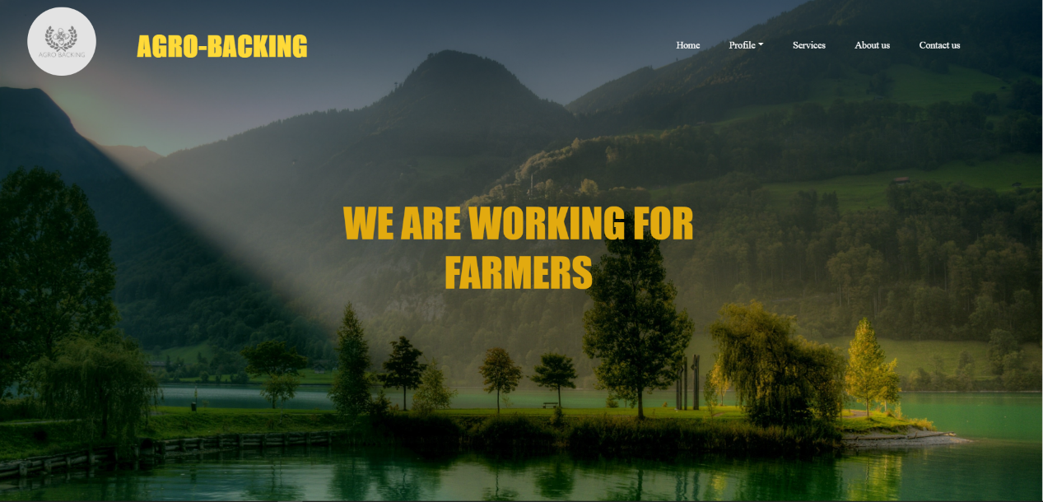

Fig:10.1 Home Page

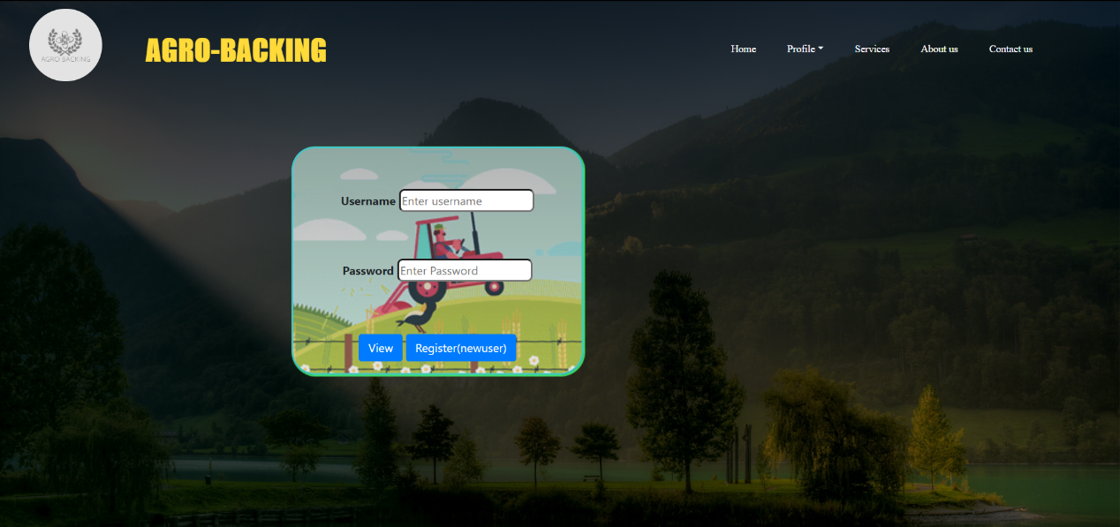

Fig:10.2 Login Page

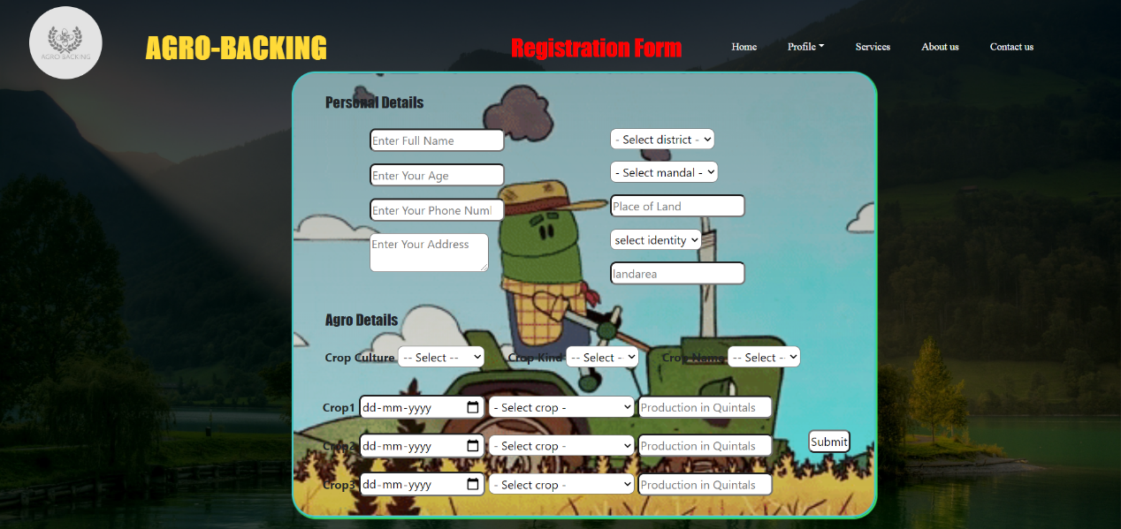

Fig:10.3 Registration Page

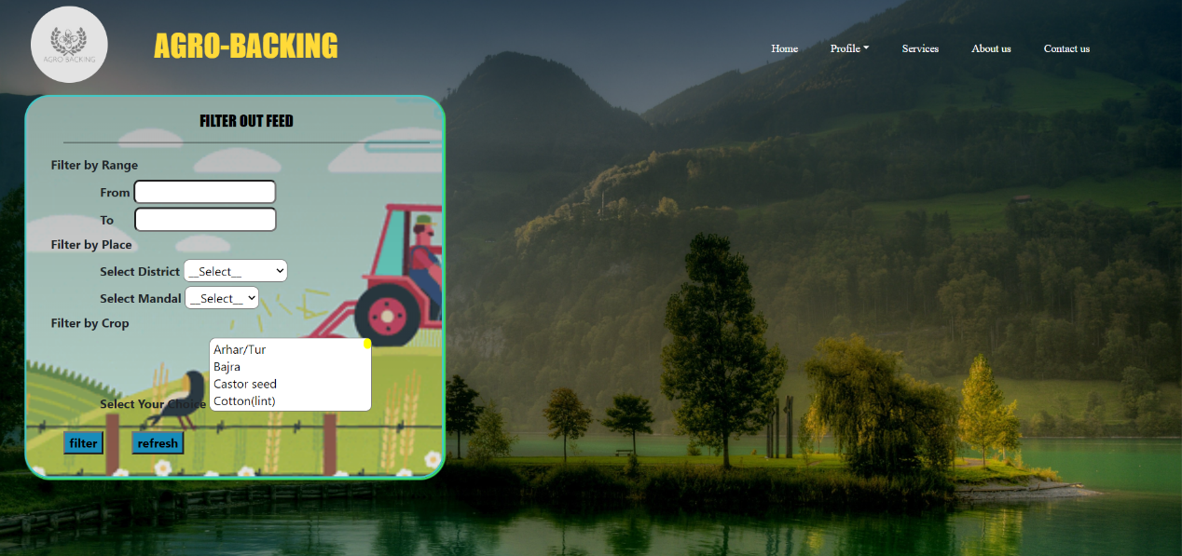

Fig:10.4 Services Page

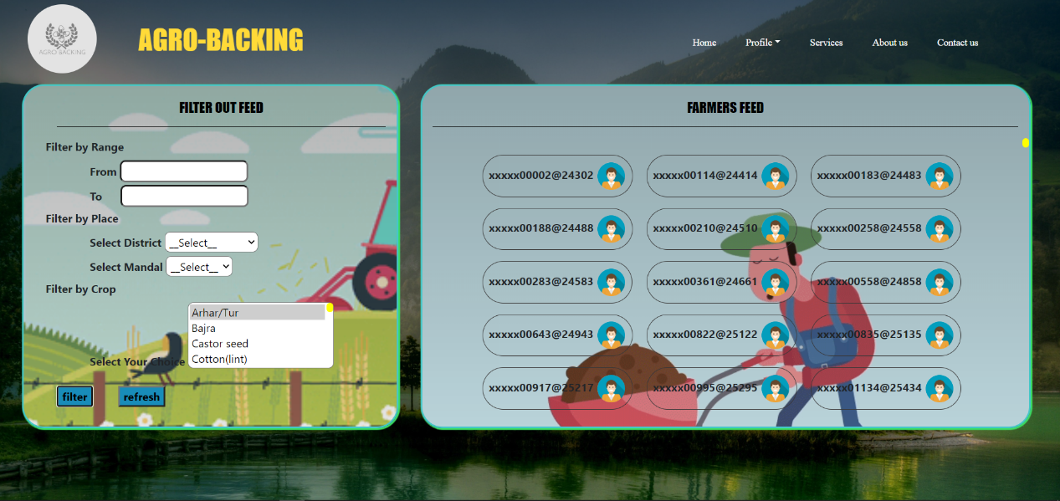

Fig:10.4.1 Services Page (Farmers list)

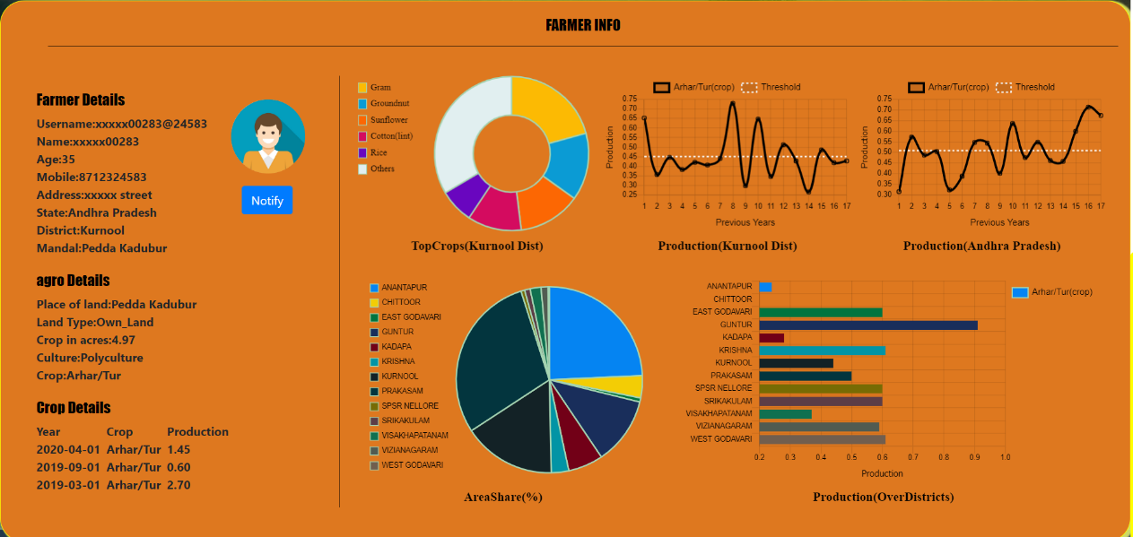

Fig:10.4.2 Services Page (Farmer info)

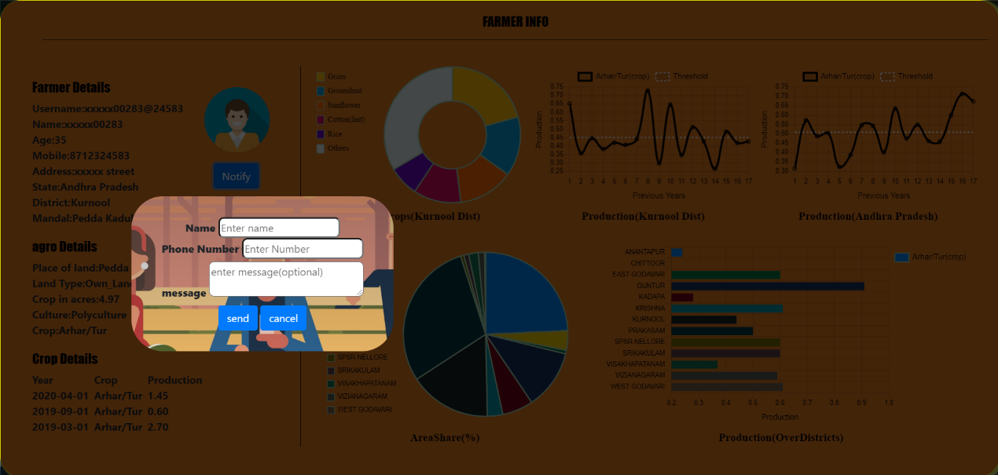

Fig:10.4.2 Services Page (Notify farmer)

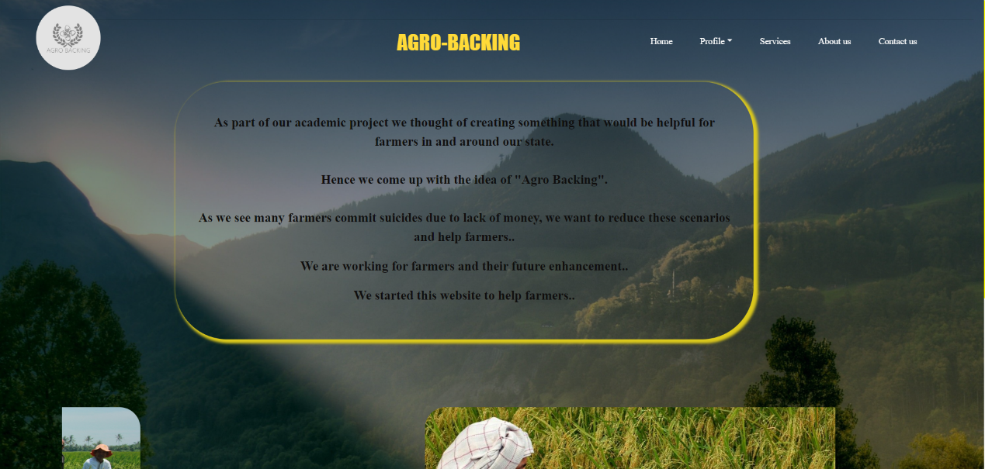

Fig:10.6 Aboutus page

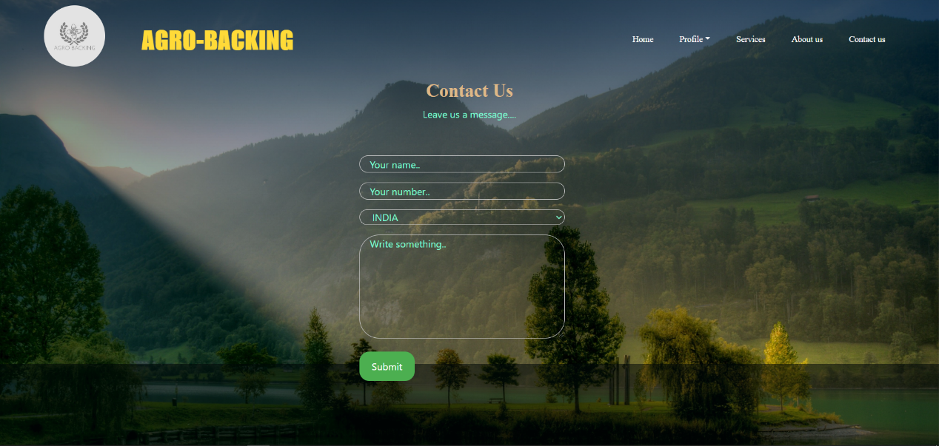

Fig:10.6 Contactus page

**CHAPTER-11**

**CONCLUSION**

In the conclusion, we would like to propose a new web application that helps farmers to get investments for their crops and there will not be ant discontinuation of farmers from farming. This web application helps in maintaining a good relationship with farmers and their problems which were not being exposed so far and attracting more and more investments from different individuals and organizations.

**CHAPTER-12**

**FUTURE WORK**

At present we are collecting various data related to farmers and their crops, in future we can attach some other services like analysing data and giving accurate results regarding the expected outcomes for all kinds of crops and different cultures. We can implement machine learning and some other concepts to analyse the different data sets collected and involve more number of investors, so that farmers will get benefitted and increase national income.

**CHAPTER-13**

**REFERENCES**